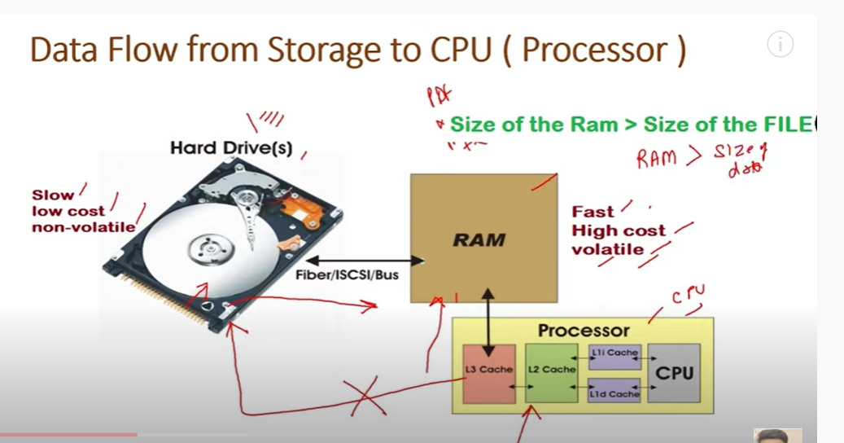

Cpu process data at dam

Zize of data should be less than ram

If size of data is so high

Then we cant have ram storage capacity much

Then :

Cluster and distributed

Parallelization

Big data:

Volume(big size)

Variety(big data decrease velocity)

Velocity

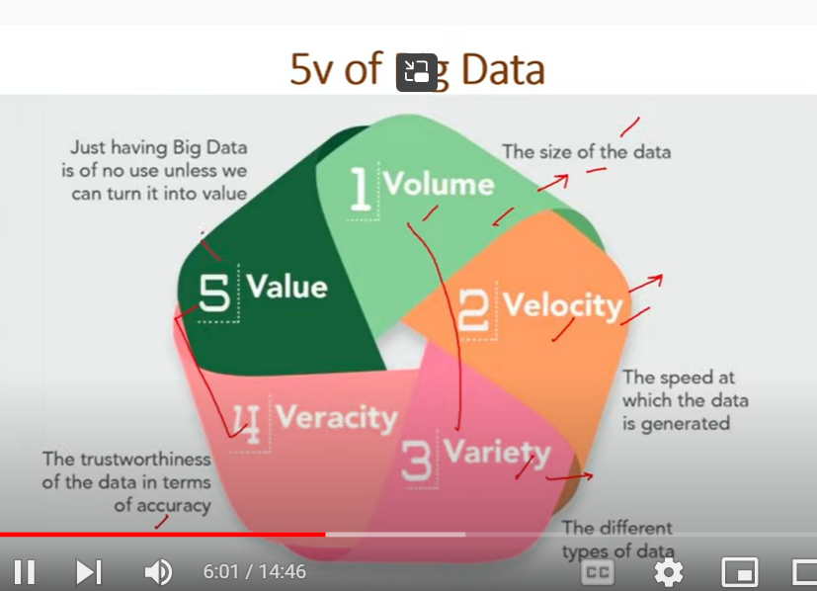

Good launched:

GFS paper

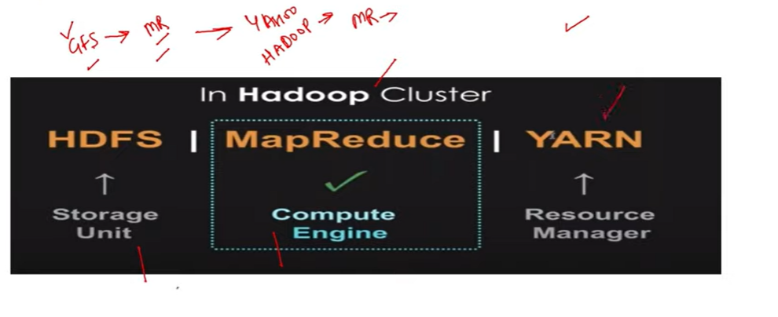

Map reduce: compute engine

Map: did operations in small parts in parallel

Reduce : combine all results

YARN:

Recourse manager

Node manager

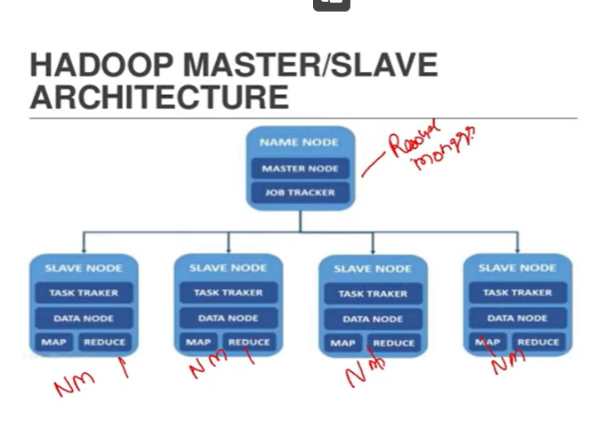

Task comes to master node

Assign to resource manager

--

Apache spark

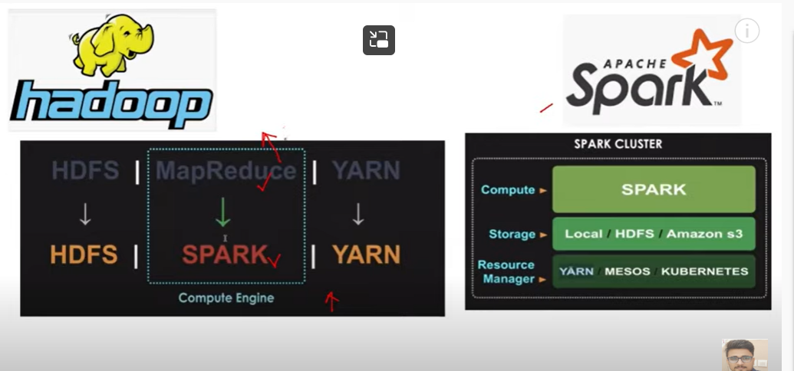

We are just replacing map reduce with spark

Remaining parks same

--

If we are using hdfc and yarn in spark: we can call that as spark distributed environment

If we have others: spark stand alone

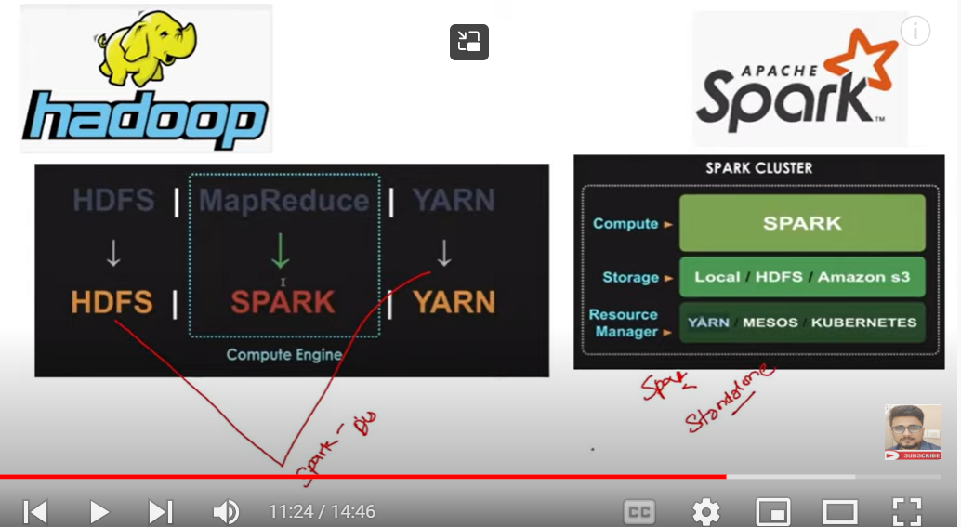



Hadoop; java based

Spark:

In memory computations: data stored in ram, so reading and writing takes fast

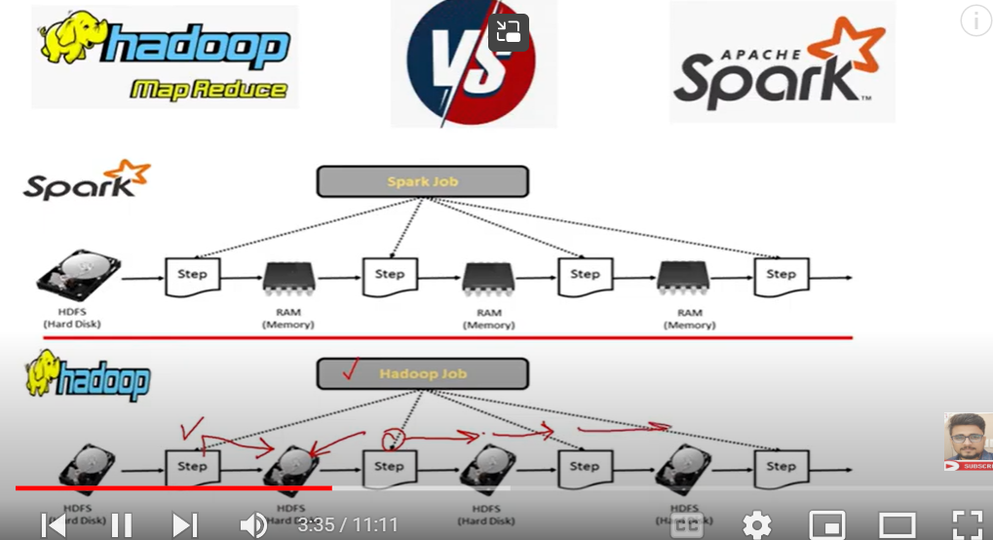

Lazy execution:

When ever we are applying some function to read data, it will not read data until and unless we does some performance

It will just check syntax

Parallel processing: distr of work to diff nodes

Hadoop: only for batch processing

Spark supports: batch and real time processing

Spark uses : Hadoop for file storage

Spark has only computing engine

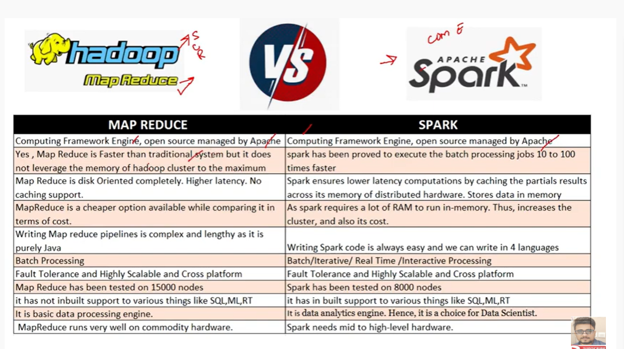

Differ between pandas and sparkDataframe

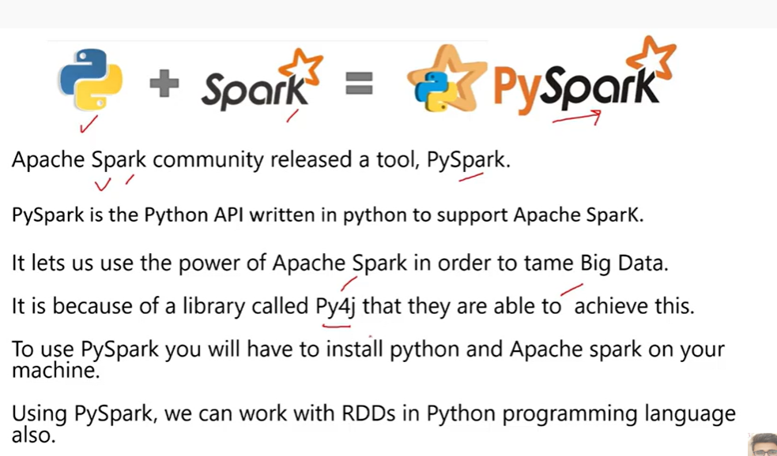

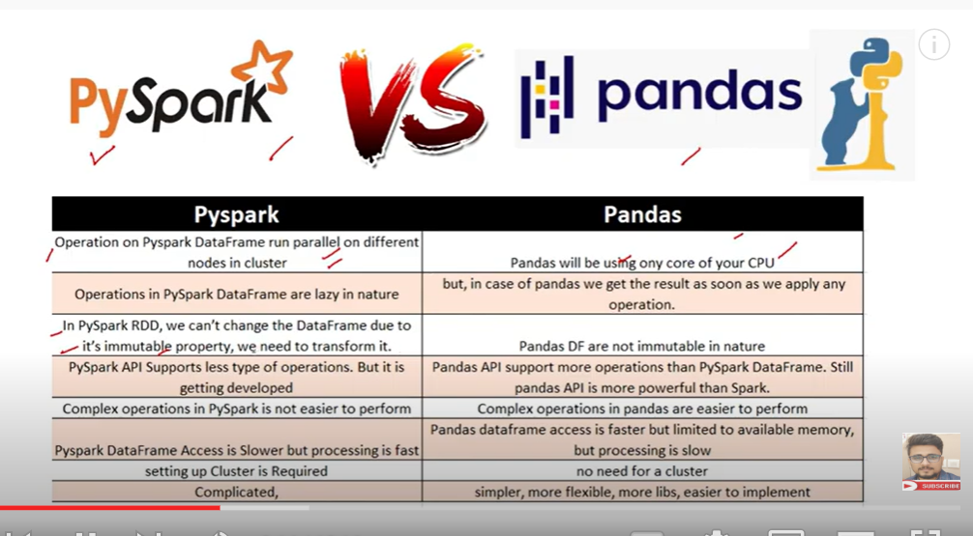

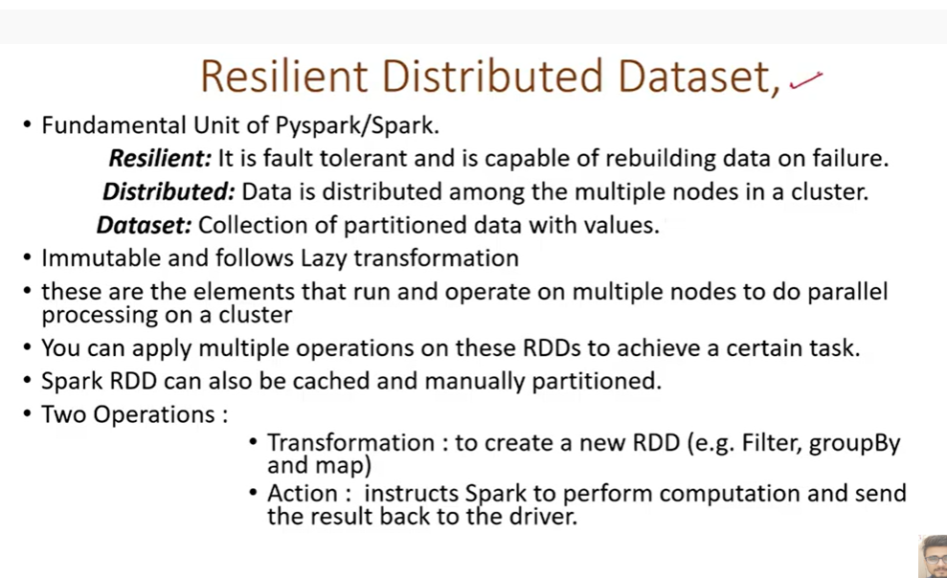

Driver is like master node

We can create many rdds

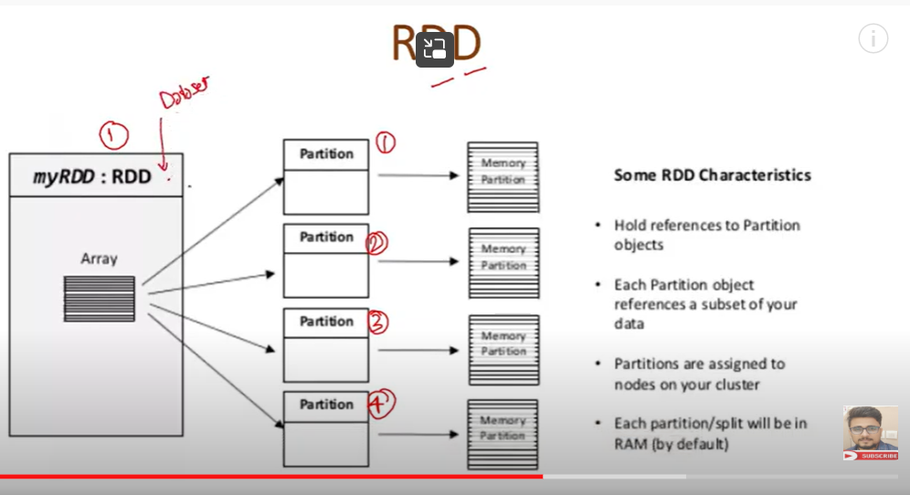

One dataset

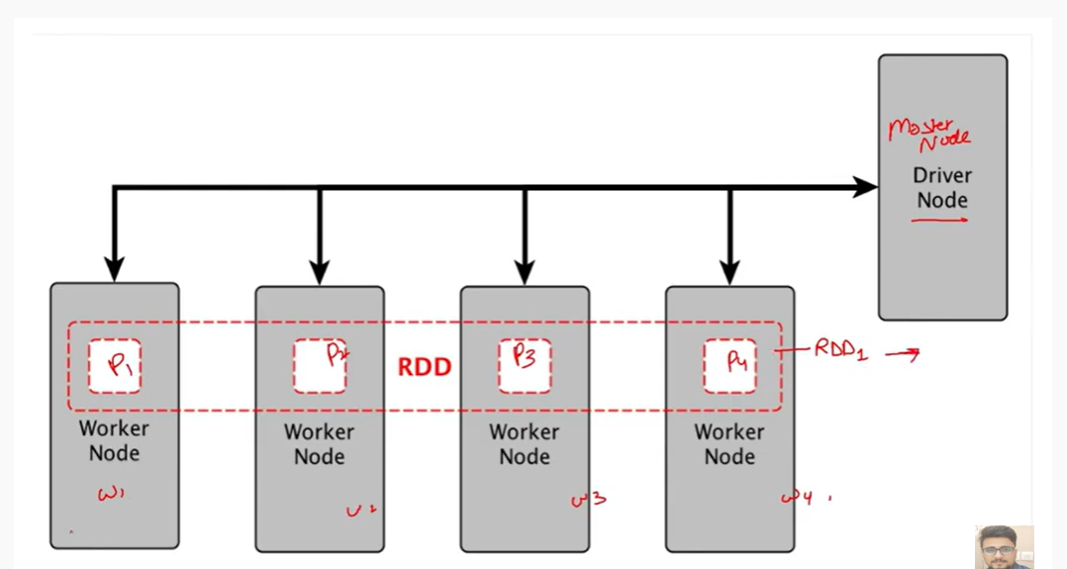

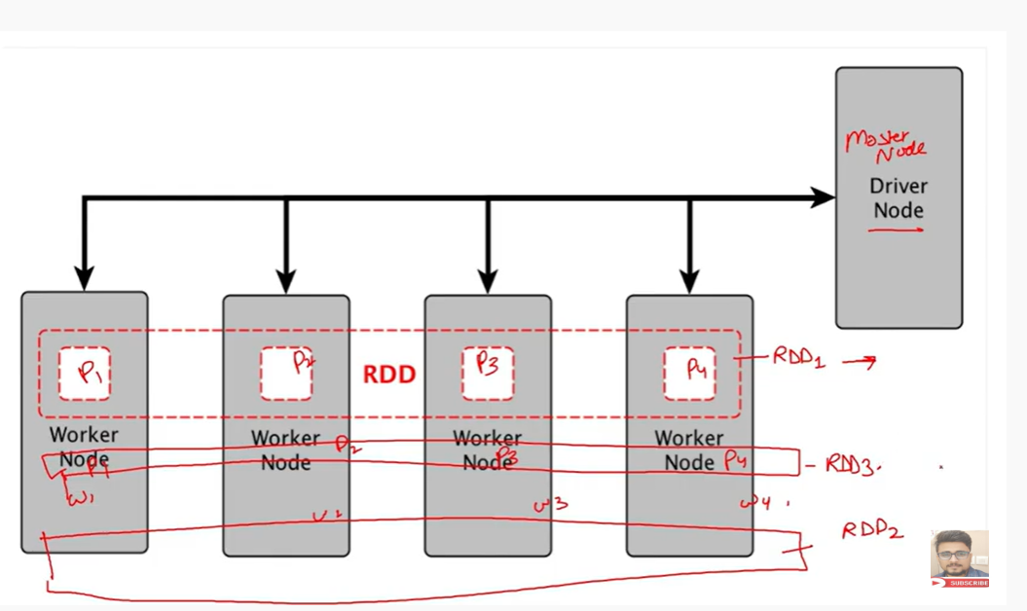

Dataset : multiple partitioned : creates diff rdd

Fault tolerance: it stores all mata data

Which had data lineage info

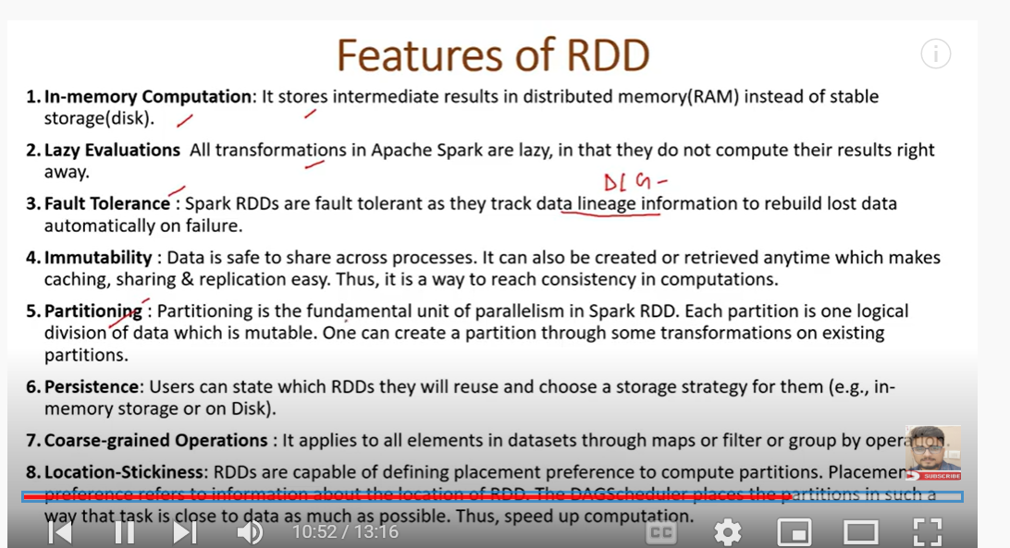

--

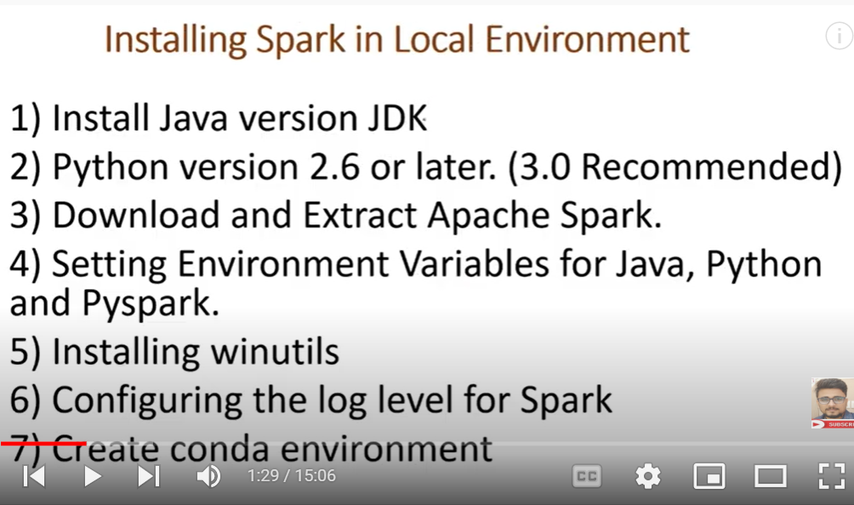

Installations

[Pyspark Installation on Windows Machine | Pyspark Installation on Google Colab | Pyspark - 4 - YouTube](https://www.youtube.com/watch?v=_28FEBeKRDs&list=PLlUZLZydkS7_8WnK8fMENmJFSfPwxw9Fi&index=4)

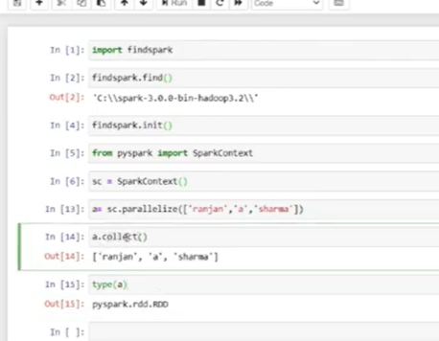

A is rdd

Collect takes all info

We use a.take(3)

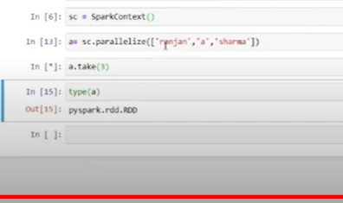

From pyspark import aparkcontext – means we are creating pyspark in local computer

Google colab

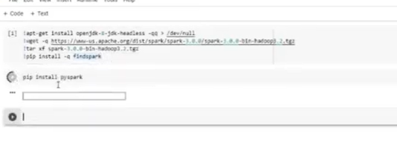

Initialize spark context

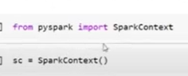

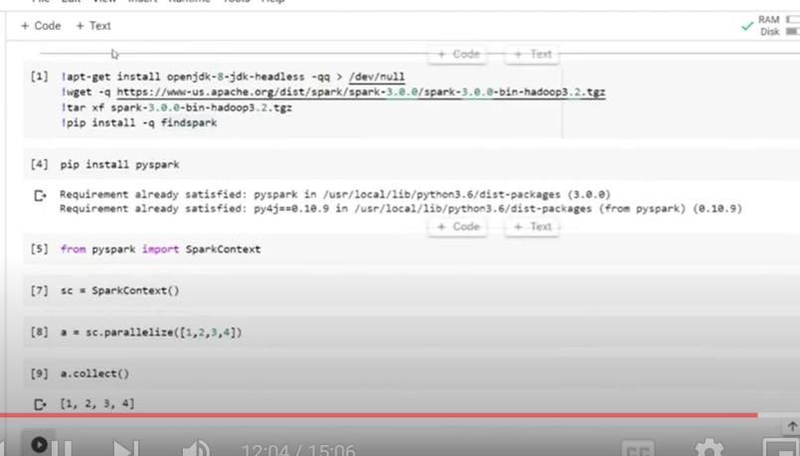

Once work is done we need to stop spark context

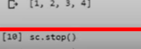

--

See whatever we have done in spark

Localhost.4040

Installations:

[Pyspark Installation on Windows Machine | Pyspark Installation on Google Colab | Pyspark - 4 - YouTube](https://www.youtube.com/watch?v=_28FEBeKRDs&list=PLlUZLZydkS7_8WnK8fMENmJFSfPwxw9Fi&index=4)

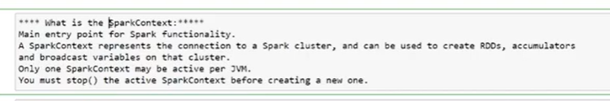

Spark context is a main entry point for to access spark feature

Gateway

It ives connection to spark

RDD: spark context

Dataframe, sql: spark session

Only one spark context allowed.

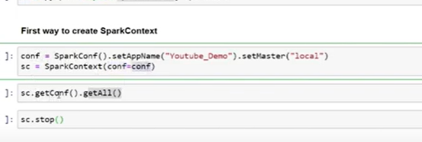

Second way to create

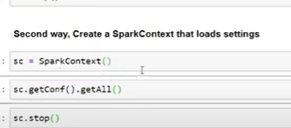

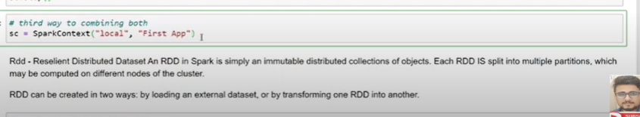

Local = master

App: first app

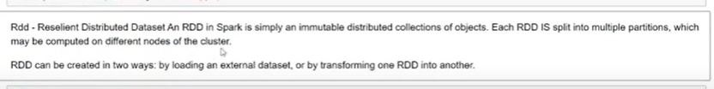

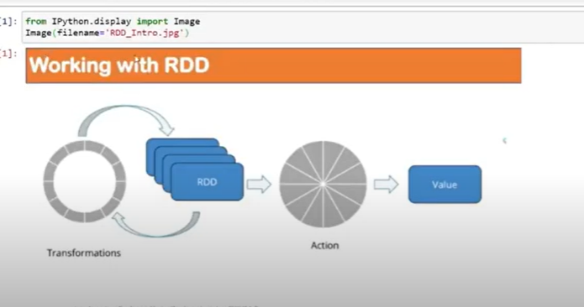

Before applying machine learning

We apply diff tasks – operations

In pysparks

Operations are devided into

Transformations- gives output rdd, lazy

Actions- gives value

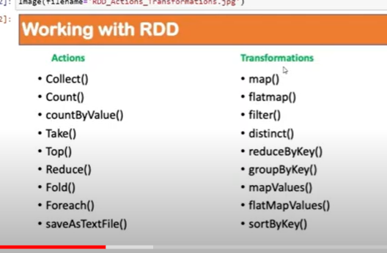

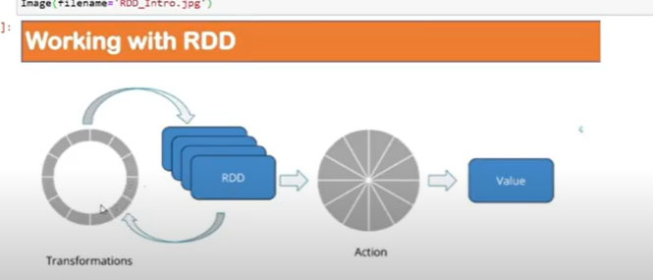

Transformations are two types:

Wide and narrow

Creating rdd:

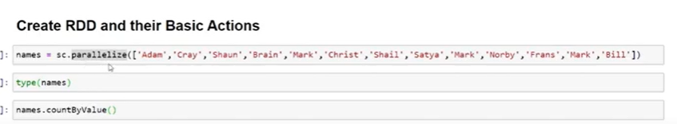

Name is variable

Parallaize: distribute among nodes

Name.collect(): -operation , it’s a action

We don’t use collect in production envt, it will give all the data(no use of pyspark)

We should use take

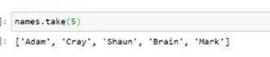

--

Now using textfile stored in directory

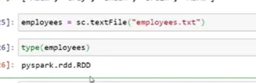

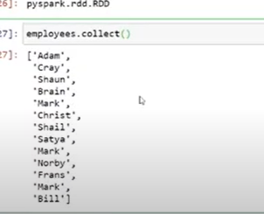

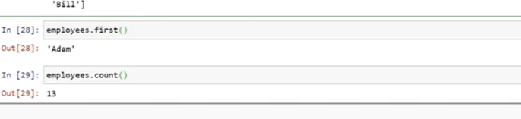

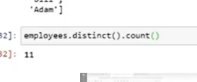

--

Creating new rdd

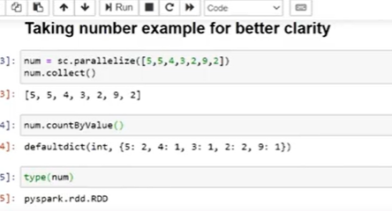

Imp function: GLOM

In spark doesn’t allow worker to refer to specific portions

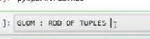

Each transformeach partition into tuples

It creates rdd of tuples

Eac store one tuple for partition

* Parameters in parallise in rdd

---another notes --

PySpark parallelize() is a function in SparkContext and is used to create an RDD from a list collection. In this article, I will explain the usage of parallelize to create RDD and how to create an empty RDD with PySpark example.

Before we start let me explain what is RDD, [Resilient Distributed Datasets (**RDD**)](https://sparkbyexamples.com/spark-rdd-tutorial/) is a fundamental data structure of PySpark, It is an immutable distributed collection of objects. Each dataset in **RDD** is divided into logical partitions, which may be computed on different nodes of the cluster.

* PySpark Parallelizing an existing collection in your driver program.

Below is an example of how to create an RDD using a parallelize method from [Sparkcontext](https://sparkbyexamples.com/spark/spark-sparkcontext/). sparkContext.parallelize([1,2,3,4,5,6,7,8,9,10]) creates an RDD with a list of Integers.

**Using sc.parallelize on PySpark Shell or REPL**

PySpark shell provides [SparkContext](https://sparkbyexamples.com/spark/spark-sparkcontext/) variable “sc”, use sc.parallelize() to create an RDD.

rdd = sc.parallelize([1,2,3,4,5,6,7,8,9,10])

Copy

**Using PySpark sparkContext.parallelize() in application**

Since PySpark 2.0, First, you need to create a [SparkSession](https://sparkbyexamples.com/pyspark/pyspark-what-is-sparksession/) which internally creates a SparkContext for you.

import pyspark

from pyspark.sql import SparkSession

spark = SparkSession.builder.appName('SparkByExamples.com').getOrCreate()

sparkContext=spark.sparkContext

Copy

Now, use sparkContext.parallelize() to create rdd from a list or collection.

rdd=sparkContext.parallelize([1,2,3,4,5])

rddCollect = rdd.collect()

print("Number of Partitions: "+str(rdd.getNumPartitions()))

print("Action: First element: "+str(rdd.first()))

print(rddCollect)

Copy

By executing the above program you should see below output.

Number of Partitions: 4

Action: First element: 1

[1, 2, 3, 4, 5]

Copy

parallelize() function also has another signature which additionally takes integer argument to specifies the number of partitions. Partitions are basic units of parallelism in PySpark.

Remember, RDDs in PySpark are a collection of partitions.

**create empty RDD by using sparkContext.parallelize**

Some times we may need to create empty RDD and you can also use parallelize() in order to create it.

emptyRDD = sparkContext.emptyRDD()

emptyRDD2 = rdd=sparkContext.parallelize([])

print("is Empty RDD : "+str(emptyRDD2.isEmpty()))

* Another notes—

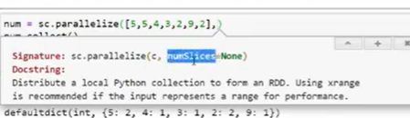

Number of partion

Default =1 \

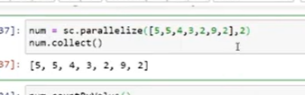

2 partitioned

Now for 3

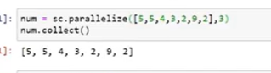

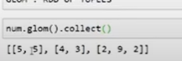

First index

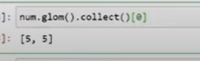

But without glom we cant access elements by indexing

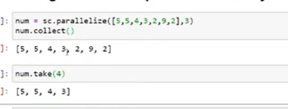

If we mention 4 in take, it will give all elements upto 4

If we create 9

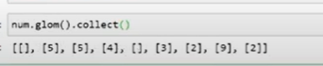

It will give some empty places

Num alone with glue is pipeline rdd

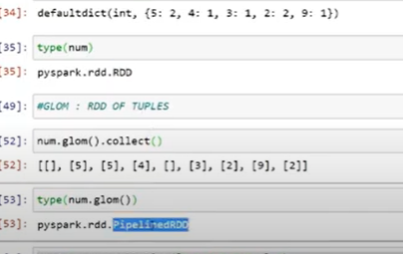

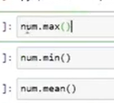

Now ..

Action_ reduce

Reduce is exactly same as reduce in lamda

Adding and reduce to one num

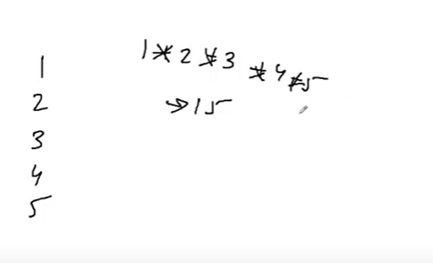

Reduce is example of action

Diff between reduce and fold:

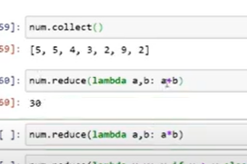

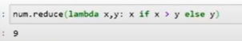

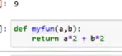

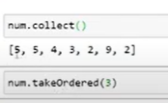

Random – first 3

Takewith oder

Ordered

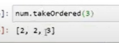

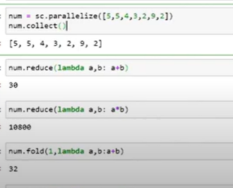

Now see how fold will work?

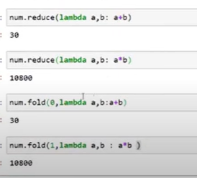

Fold 1 result same as multiplication

But with fold 1 diff

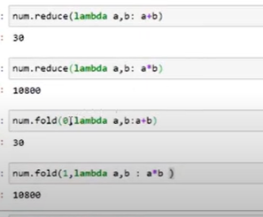

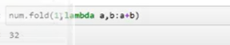

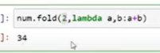

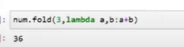

Whenever we are creating rdd by default as 1 partition

When we mention 1 partition

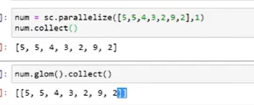

It will be having 2 brackets it means it will add 2

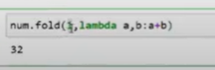

If we add 2

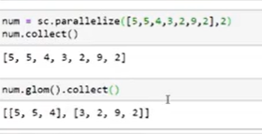

Add 2 , 3 brackets

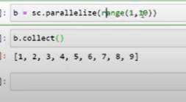

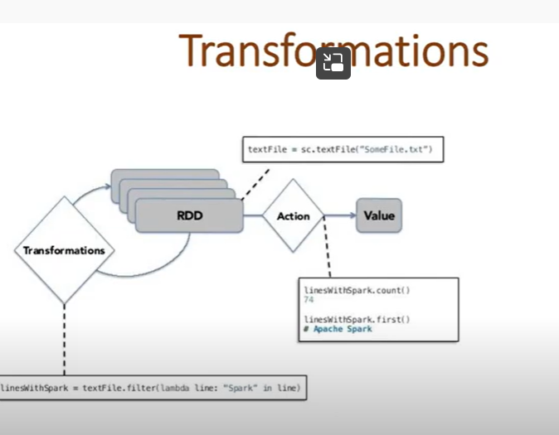

Operation

Input as rdd

Produce output as rdd

It will just see syntax or tag

It will create rdd on that when we apply some action

So trasf called lazy

It will be creating graphs DAG

2 types: narrow and wide

Narrow: pipelining

Trasf to rdd: rdd2 is created

One to one trans

When I apply filter function

It generate result

I don’t need to entire data to filter

It does filter operation on each partion

At the end it combine

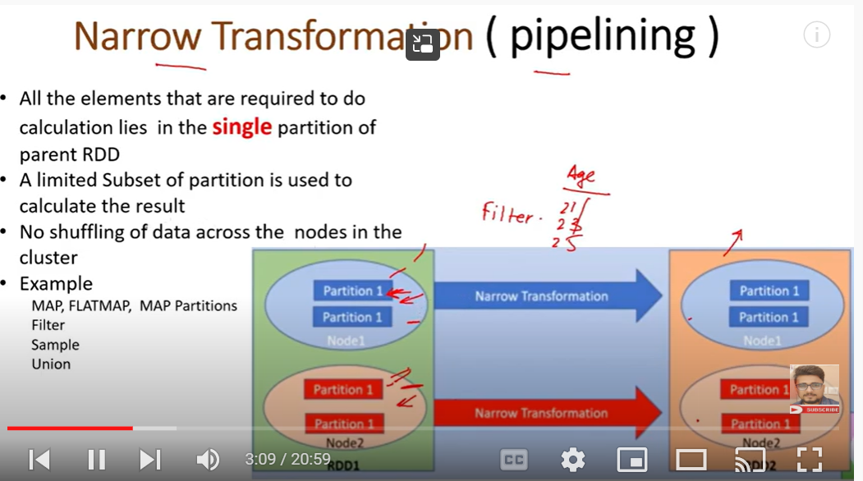

No shuffling of data between nodes

Wide: sort, it requires all data

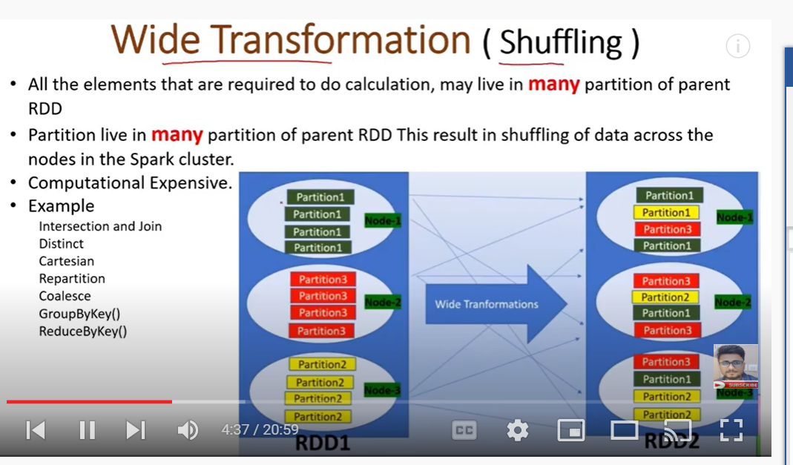

Need shuffling

If I need to search distinct

10 names in node 1

10 name in node 2

I need to search in separate in 3 notes

Then shuffle

And the find distinct

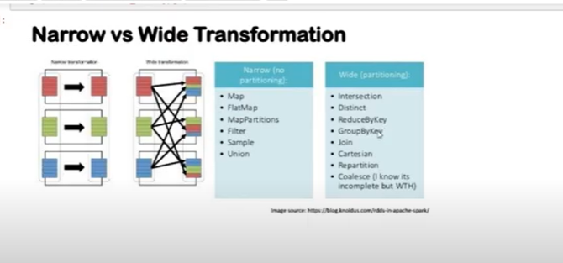

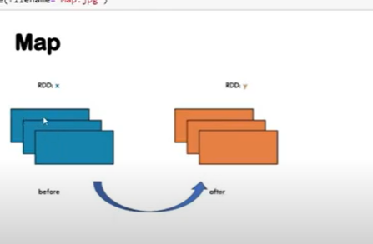

Number same but some property changed

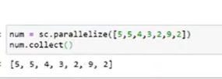

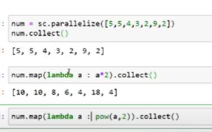

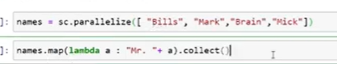

Flatmap

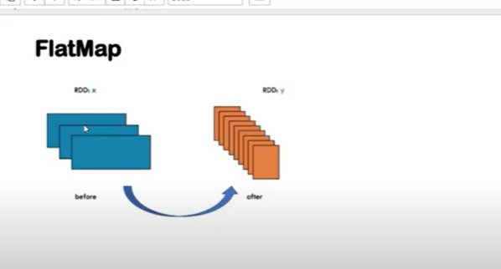

I can create one single portition to 3 diffpartions

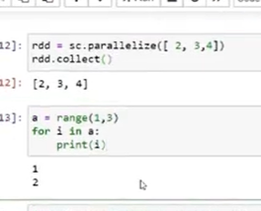

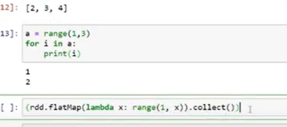

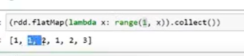

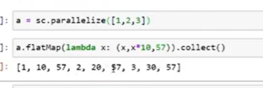

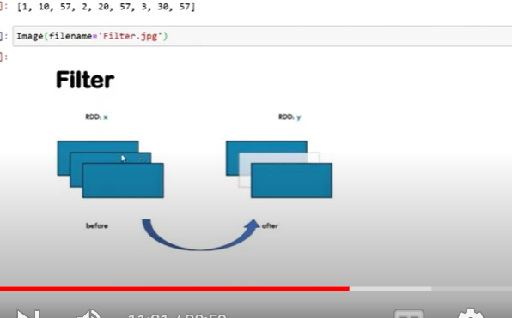

3 partitined

One disappear (if it doent match with filter criteria)

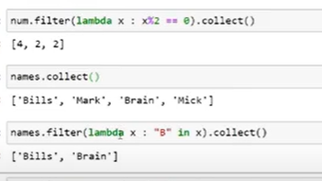

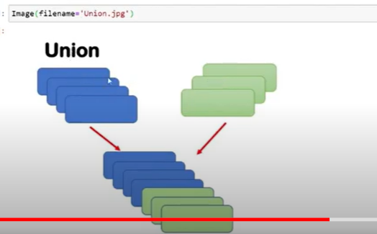

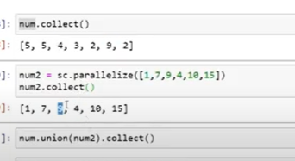

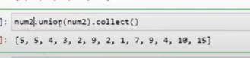

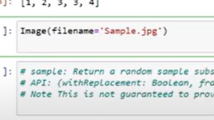

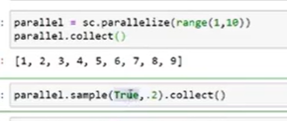

True : with replacement

Same data cant be repeated

.2 is fraction of data

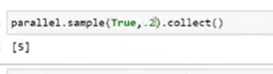

When we change or did same code, the result will be diff

To make the result same, seed

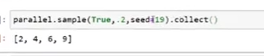

--

Wide transformation

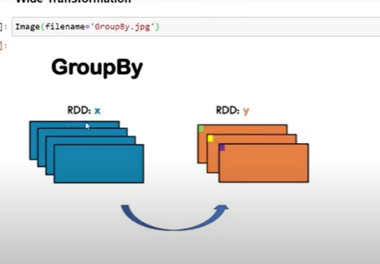

Groups based on age

Or alphabate

Groupby

Groupby with key

--

Now groupby

Creating groupby with first alphabate of name

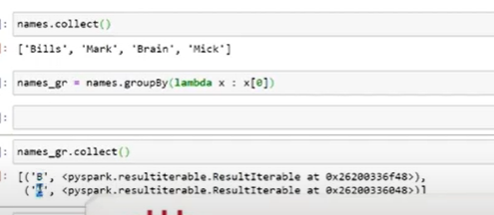

It created in key value pairs

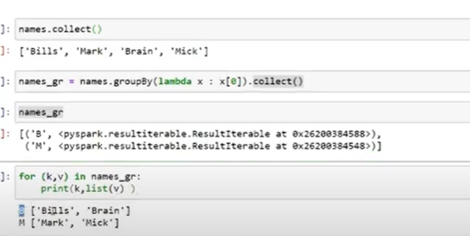

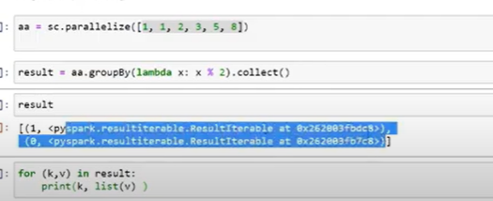

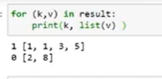

Common elements in rdd:

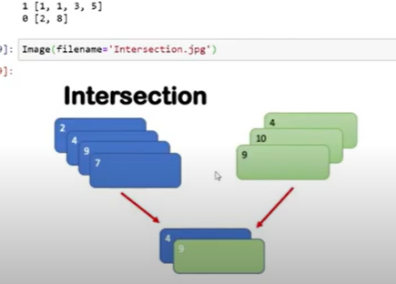

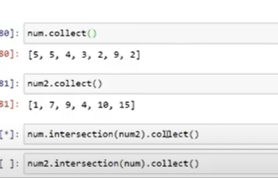

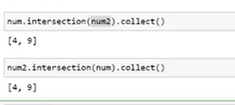

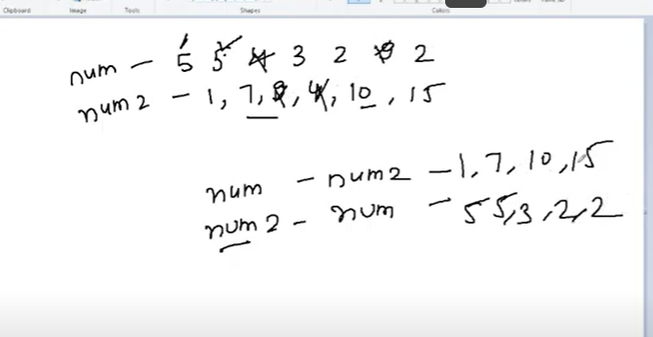

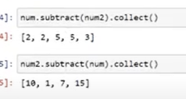

Distinct

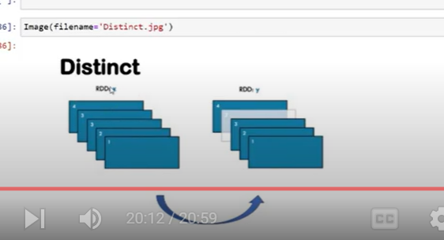

Wide Transformations on Key Value Pair RDDs

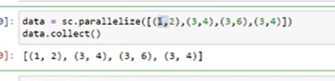

We have created tuples in list

In tuples

First value is key

2nd value is value

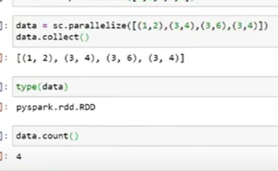

Since it has 4 key value pairs

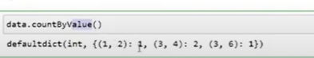

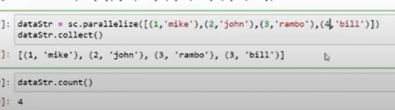

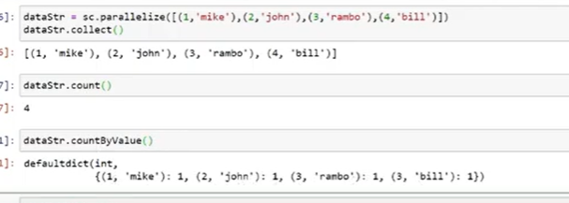

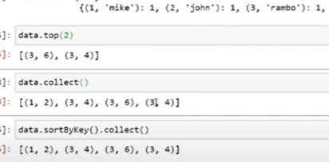

Print elements 3 as key

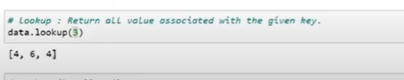

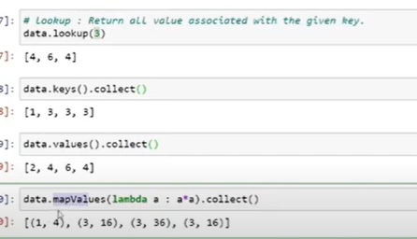

For key value pairs we don’t use

Map

Reduce

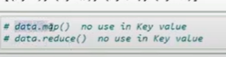

We use reduceBykey

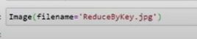

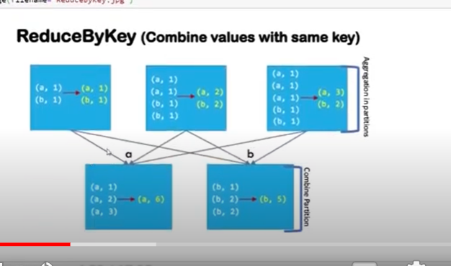

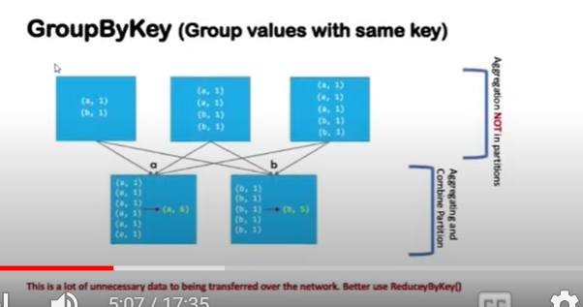

Result same

But groupby takes more computational

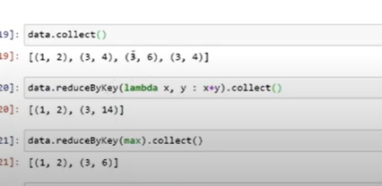

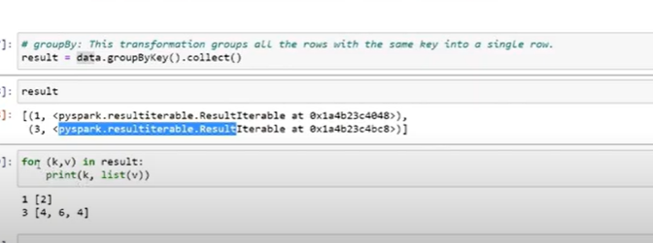

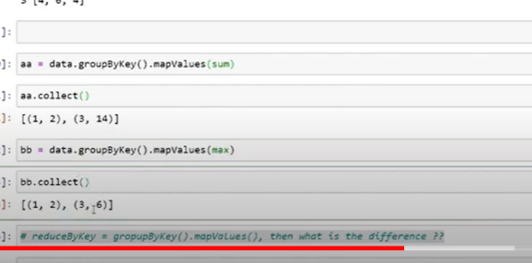

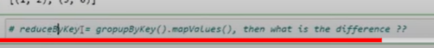

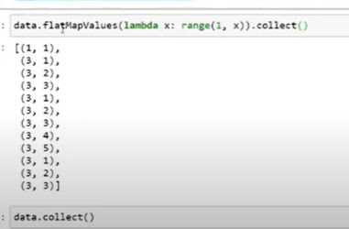

Increase the rdd length

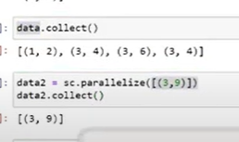

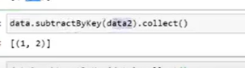

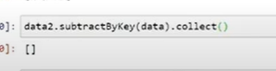

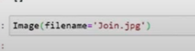

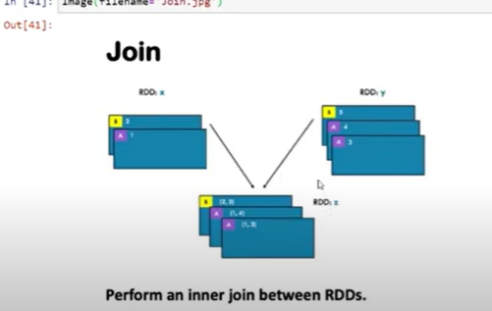

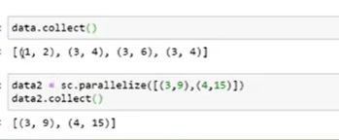

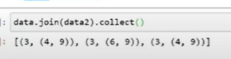

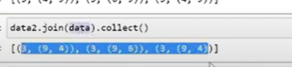

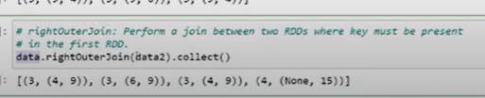

Key must be present is data2 rdd

Pref to data2

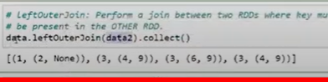

Given pref data for left join

--

In which case we don’t use rdd

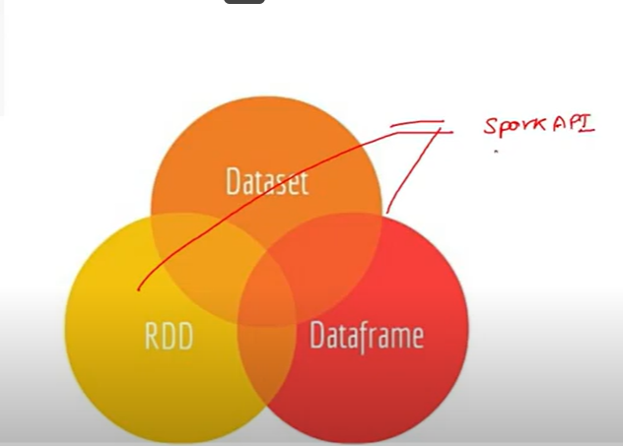

3 data storages

They shares some common features

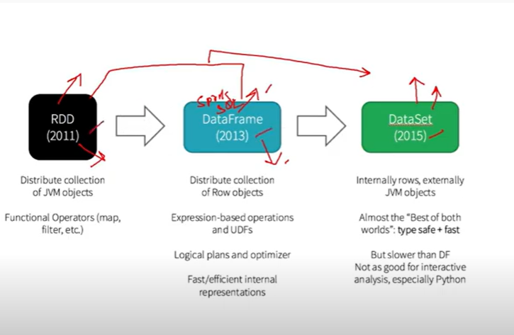

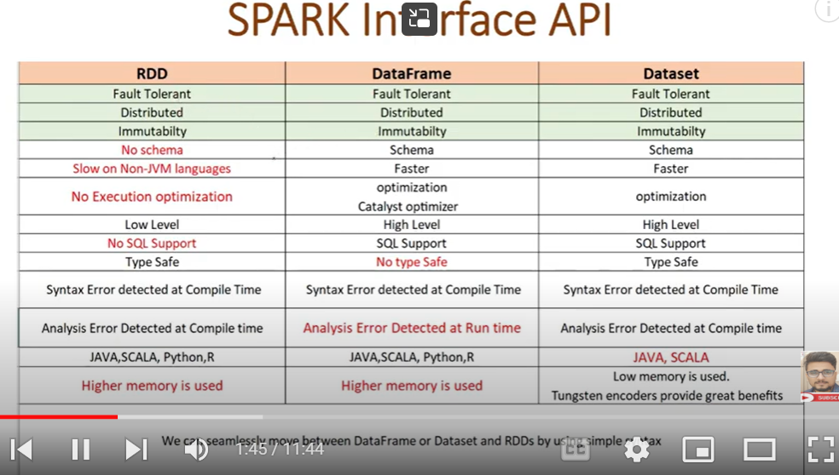

No schema , no header like structure

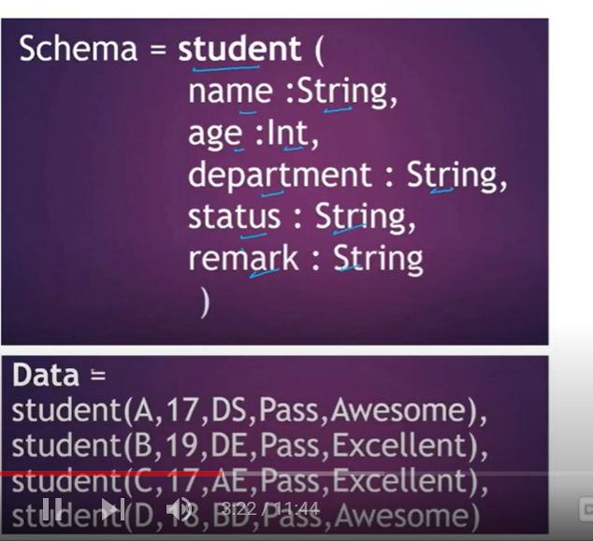

Type safe

Prevents typing error

Run time error – occurs in production time

Compile time(syntax time, while writing code)

--

Type safe, wont get error

Not type safe(it check type of data only at run time)

Spark SQL DataFrame Tutorial

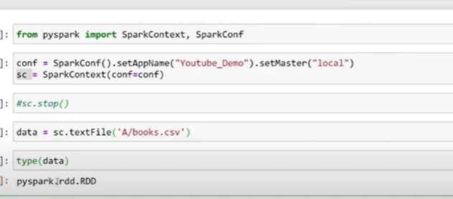

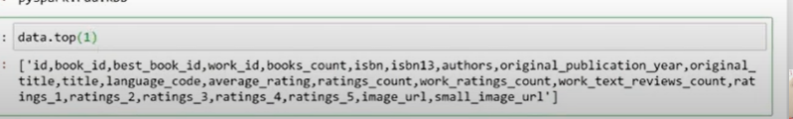

Header

Top 2 rows

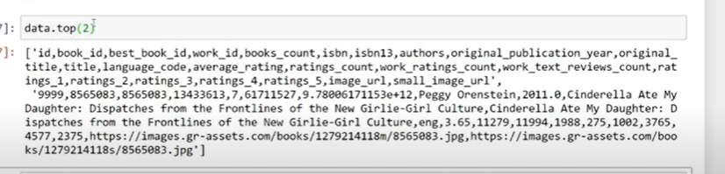

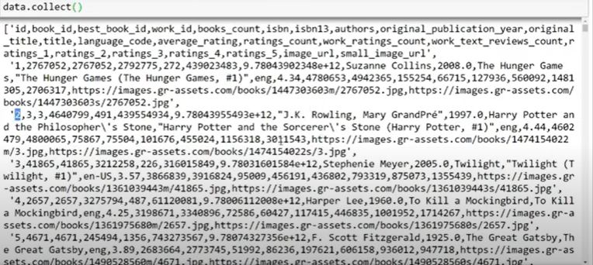

No schema like structure

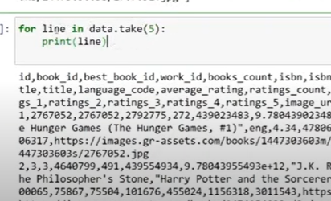

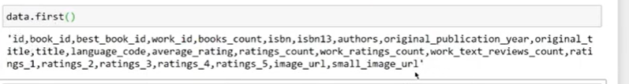

To store all columns to another variables

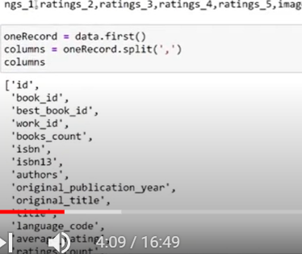

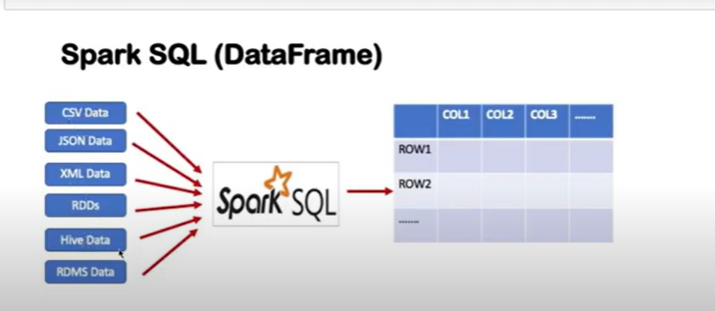

Sql in row and table form

After spark 2

We can use both spark context

Spark session

To access to spark

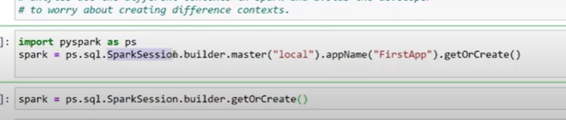

Master is not mandatory

Or



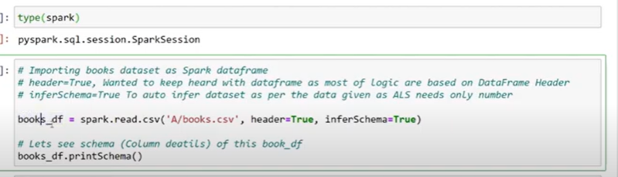

Header as true: it will create first row as header

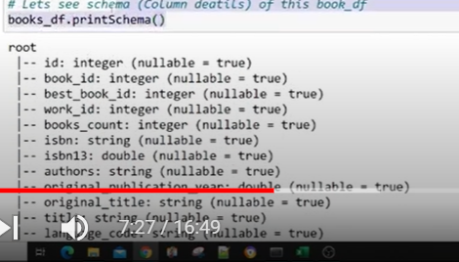

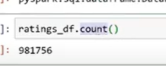

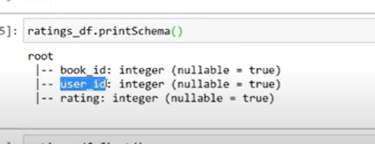

Since header is true

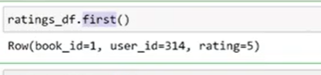

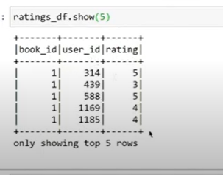

Select is like sql

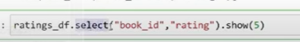

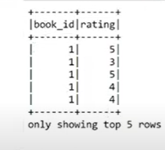

Filter is like where in sql

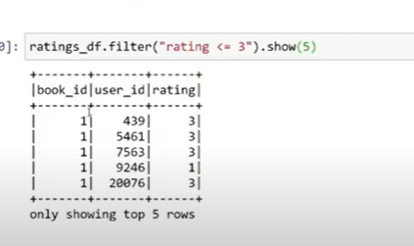

Select and filter

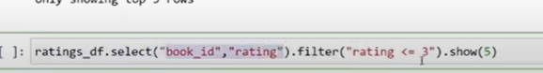

Unique count

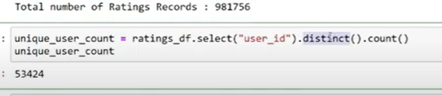

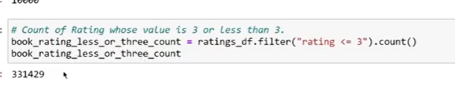

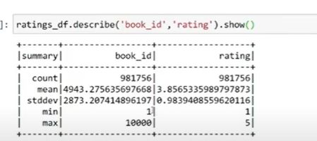

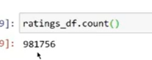

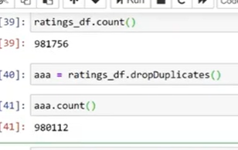

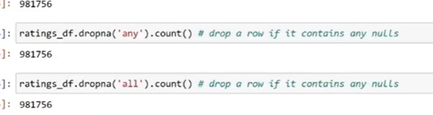

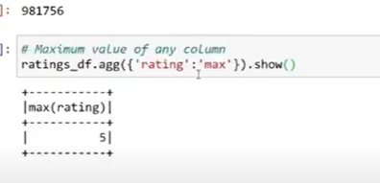

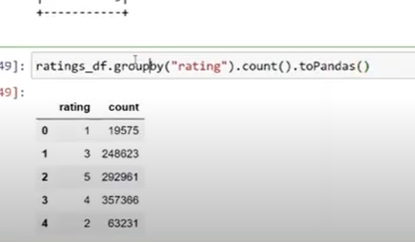

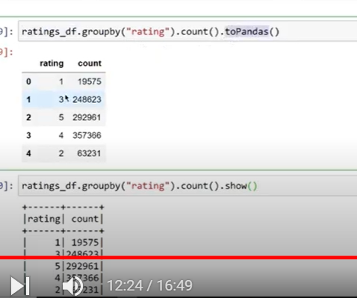

Below gives sql dataframe

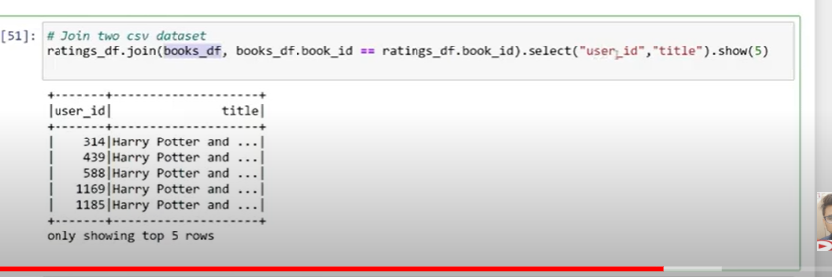

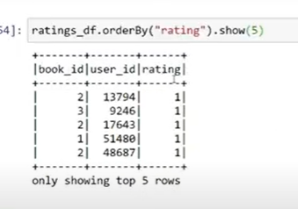

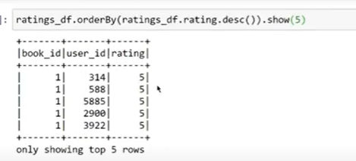

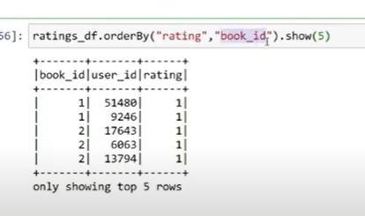

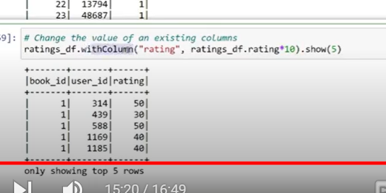

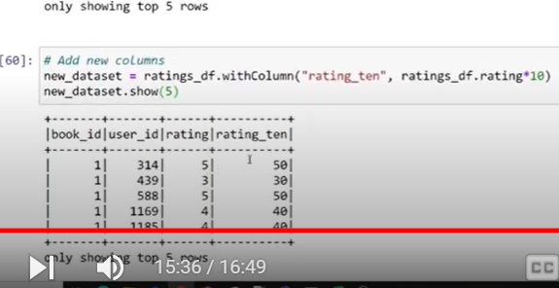

We cant over write but we can add new

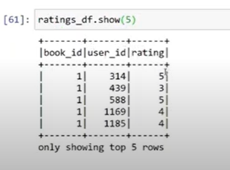

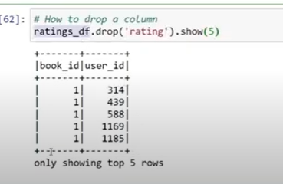

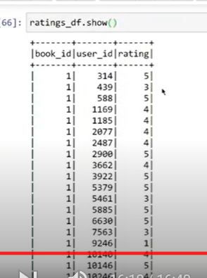

By default it show 20

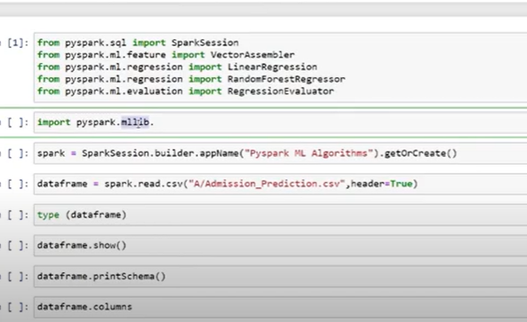

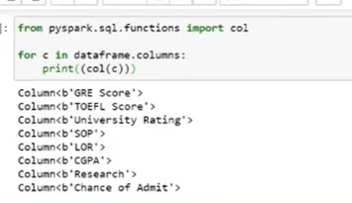

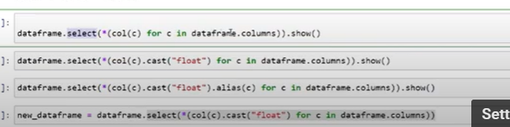

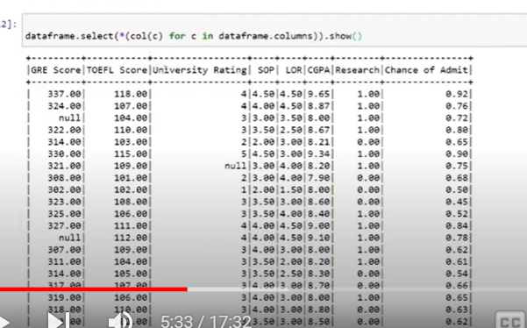

Converted all data into float

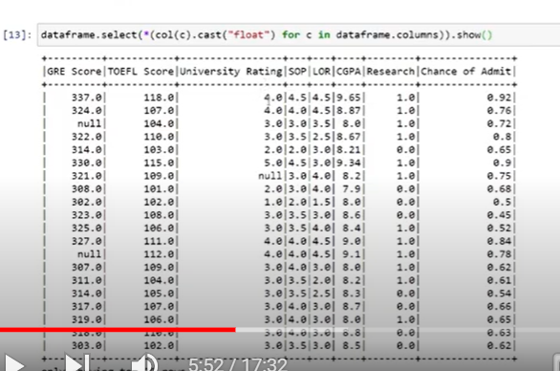

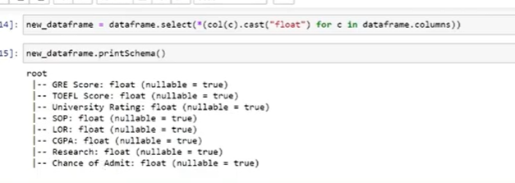

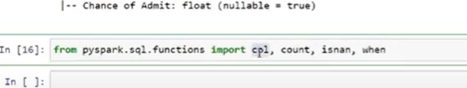

When = where sql



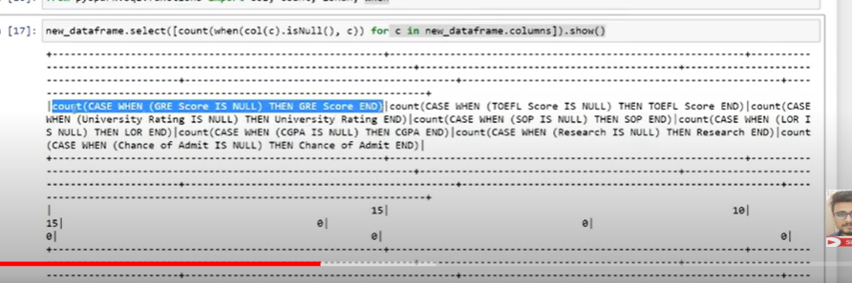

Use alias

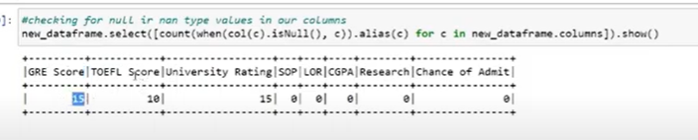

Use alias

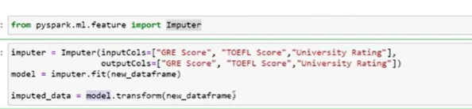

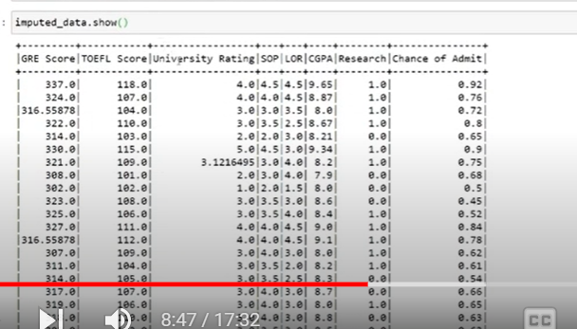

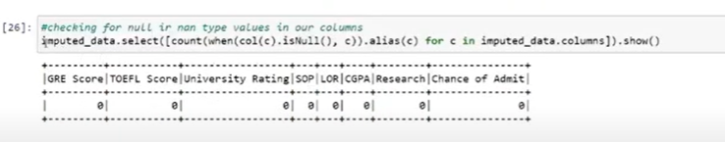

Drop out put

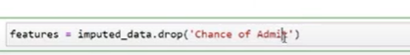

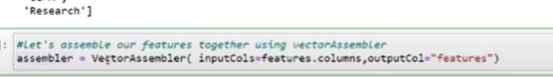

It takes all features ascolumn

Cleats new column with all columns as vectors

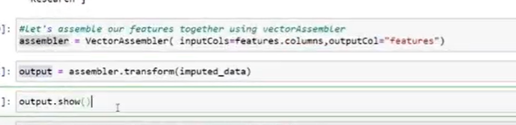

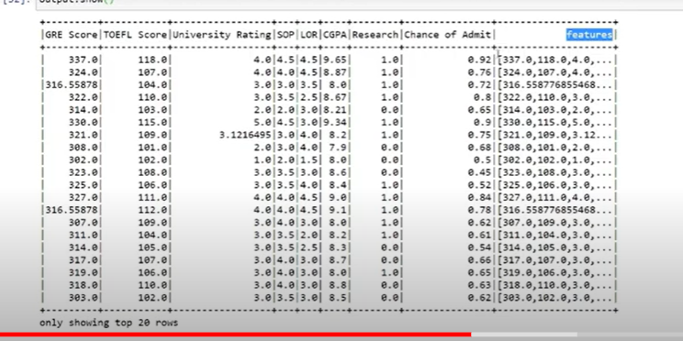

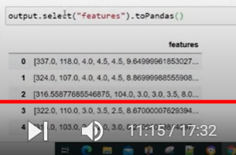

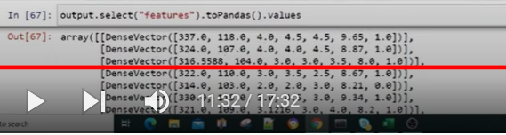

Created dense vector

Now take out 2 columns

Input

Output

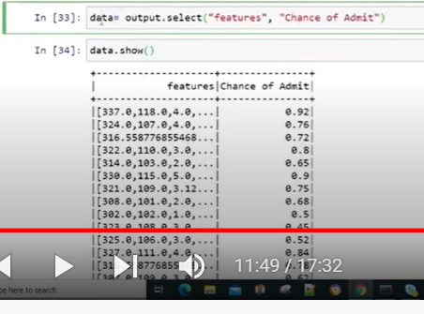

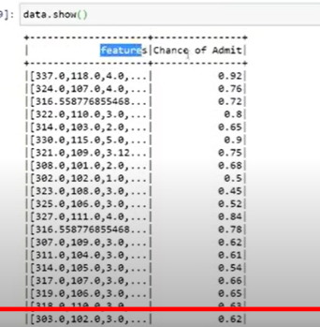

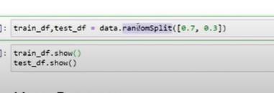

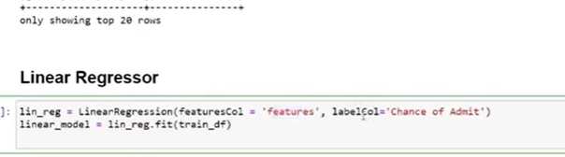

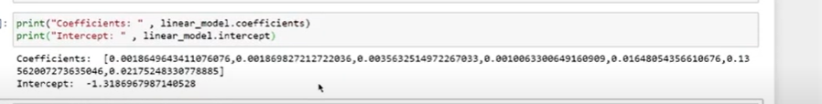

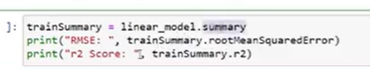

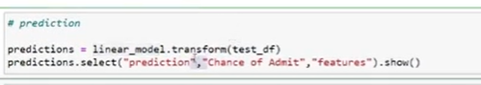

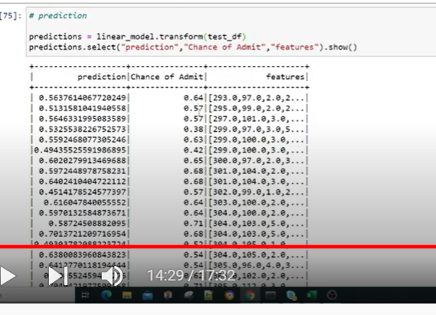

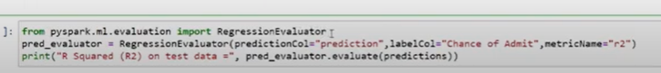

Without data preprocessing giving good results

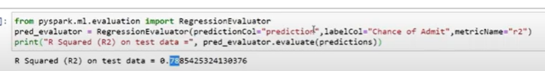

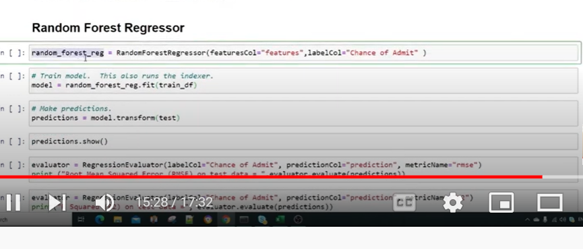

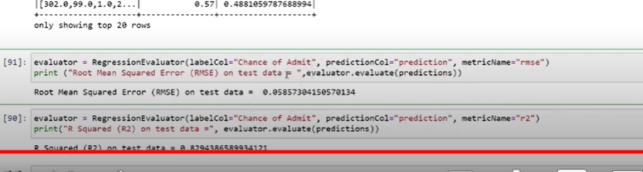

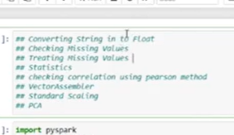

String to float

To import all functions

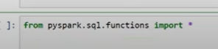

To know list of functions’

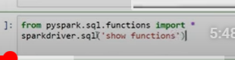

It will load as dataframe ‘

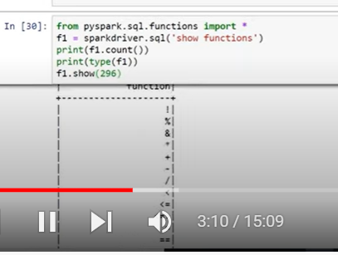

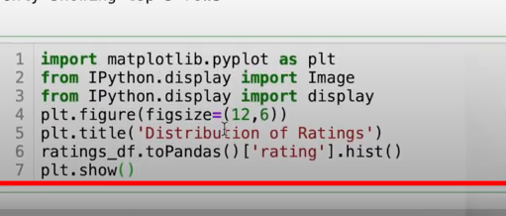

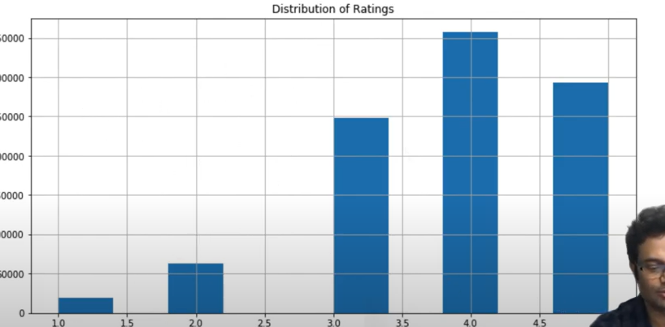

Spark Tutorial | Spark Streaming Intro | DStream vs RDD | Apache PySpark for Beginners | Part - 7

Diff between normal rdd

Streaming rdd

Normal rdd: batch files like table

Data steaming : continuous data

Once we get the data from steaming likes like

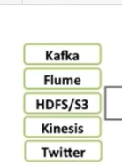

Once we get that data in dataframe

That data is called d rdd

Then this data will be distributed in spark engine

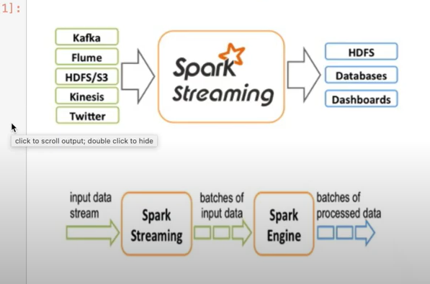

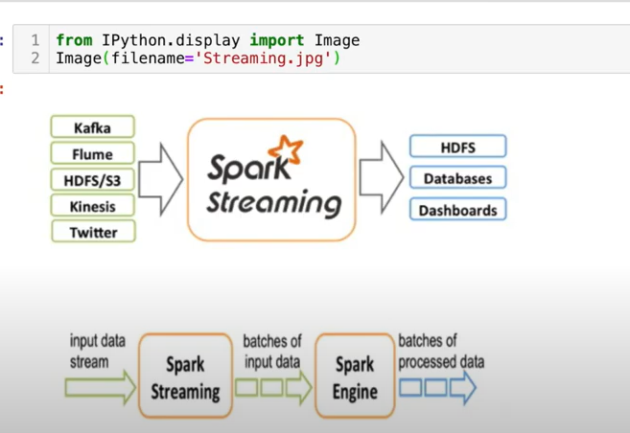

For doing streaming we need streaming context

In steaming context

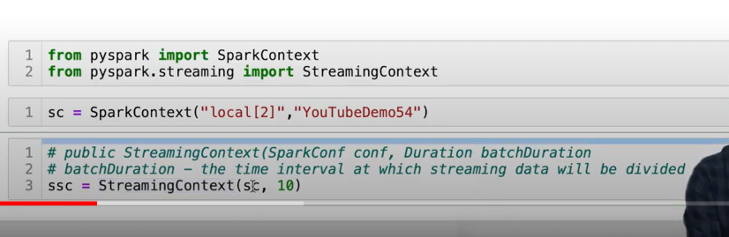

It takes 2 parameters

Needs spark context

2. batch duration (10)

At what intervals we want those data tie as batch and send

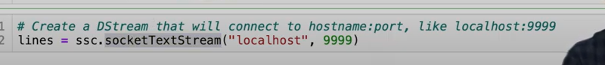

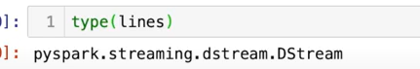

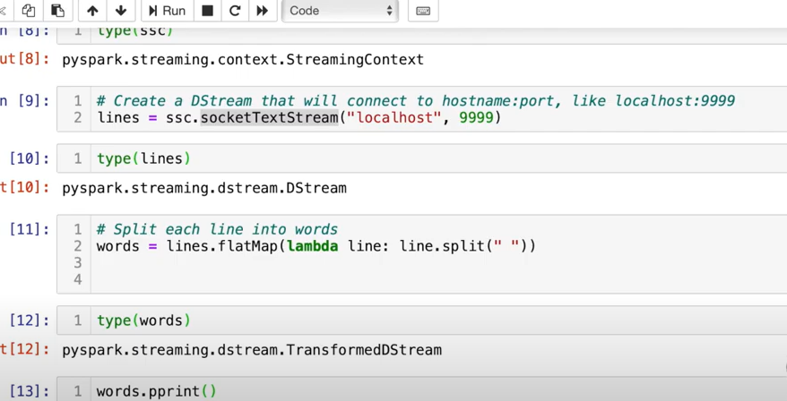

Open any cmd



Port num

After this

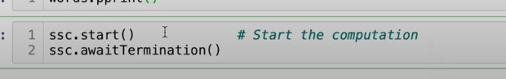

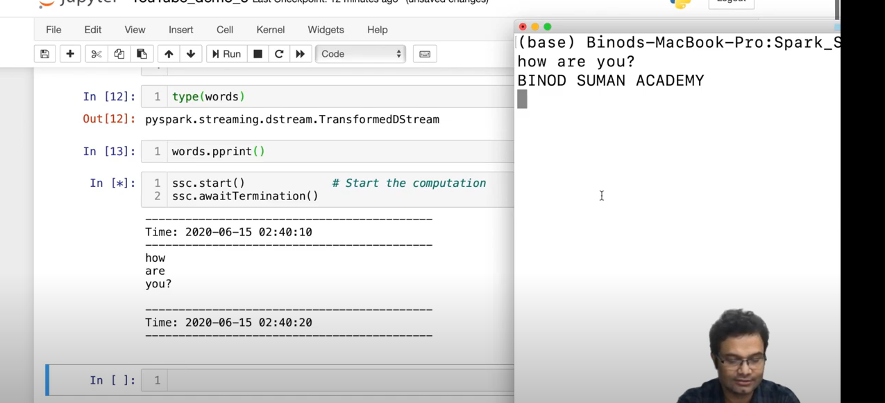

Every 10 sec taling data

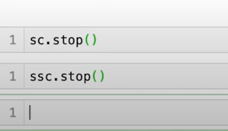

park Feature Transformation | StringIndexer | OneHotEncoderEstimator | Vector

based on freq

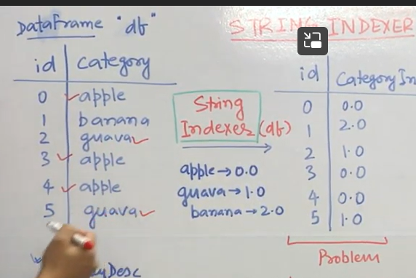

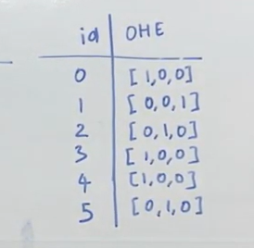

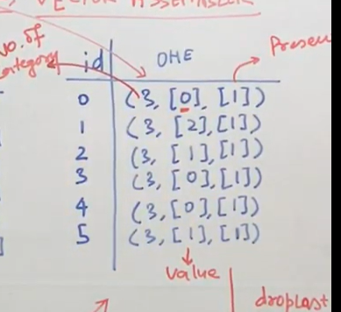

Dropping one category

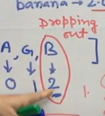

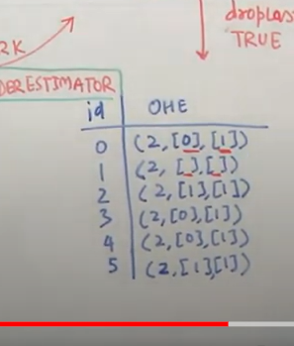

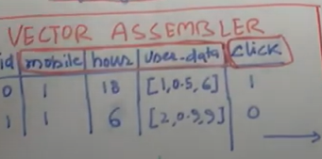

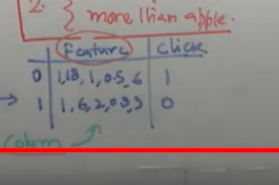



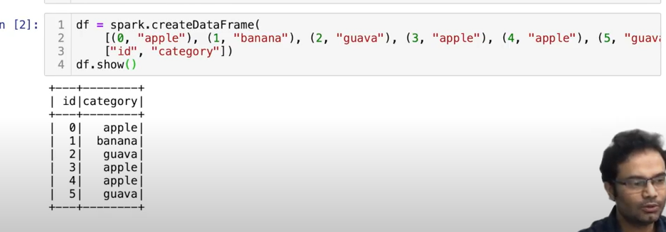

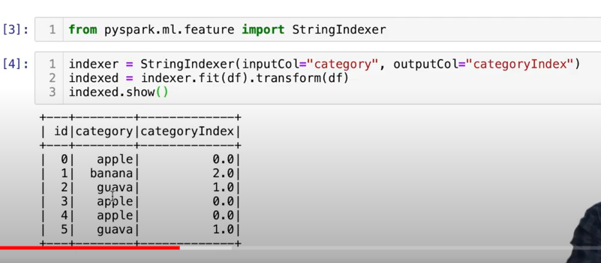

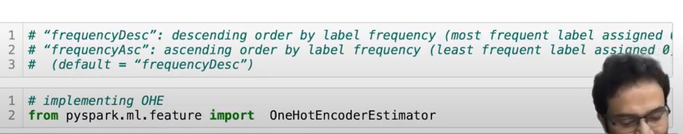

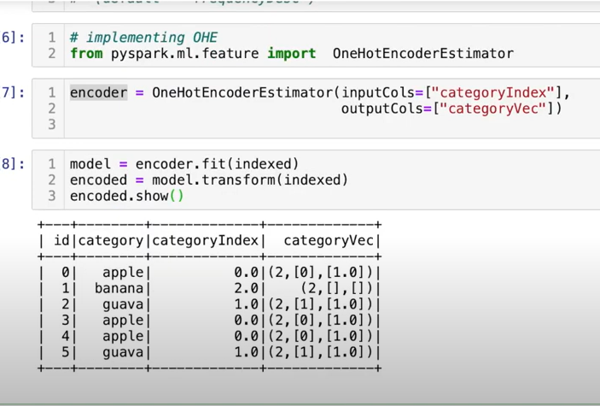

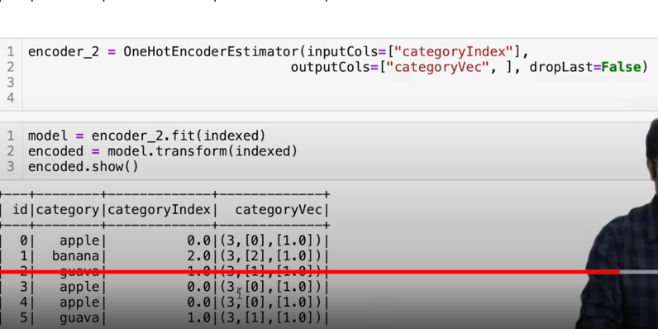

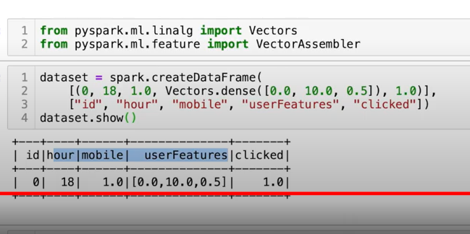

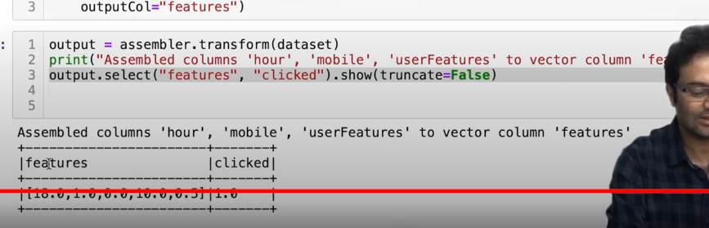

Spark Tutorial | Build your first Machine Learning Model | Classification | PySpark | Part - 10

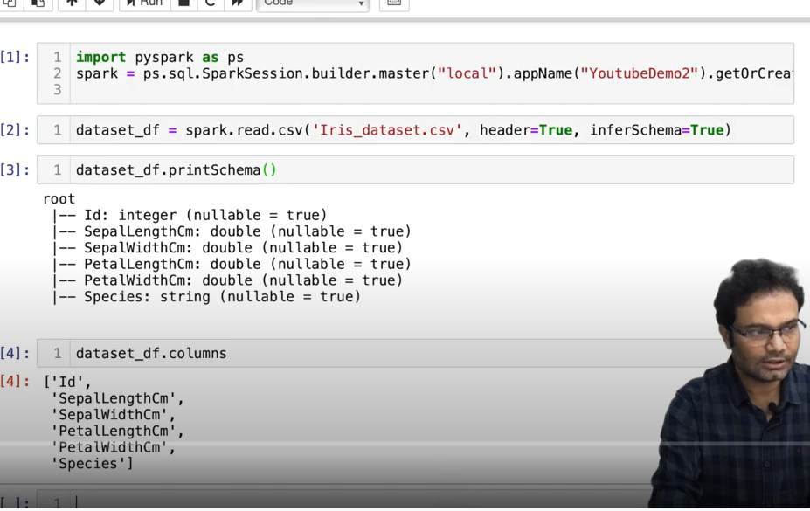

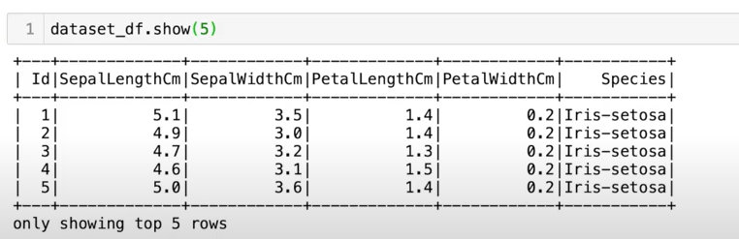

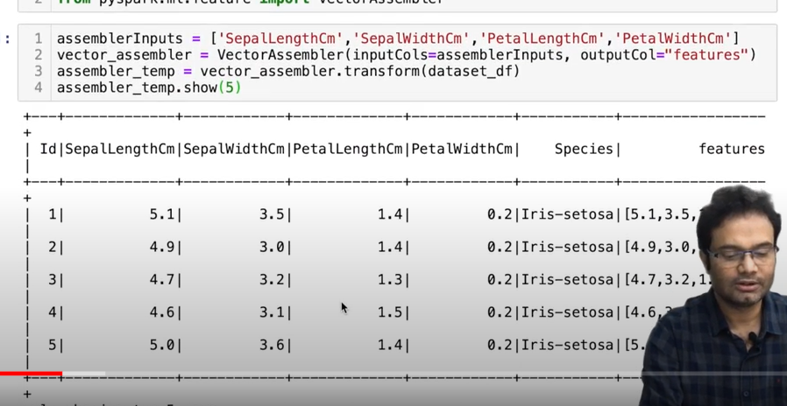

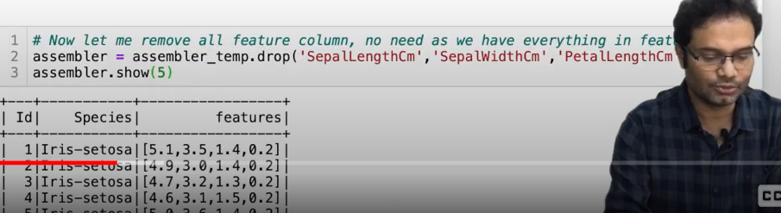

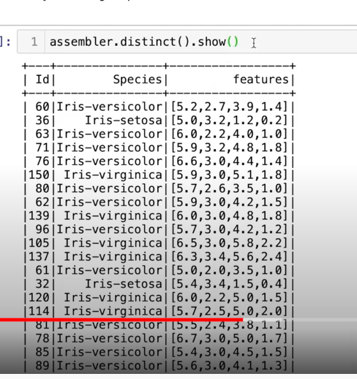

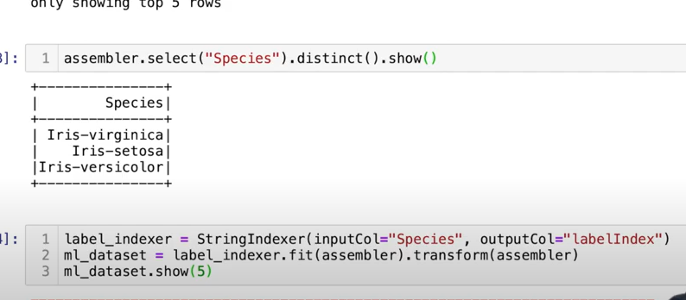

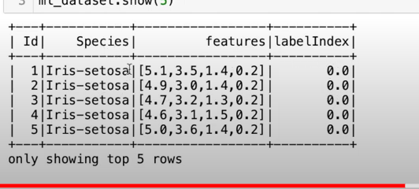

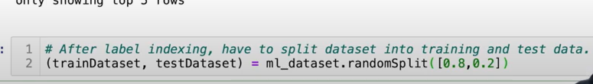

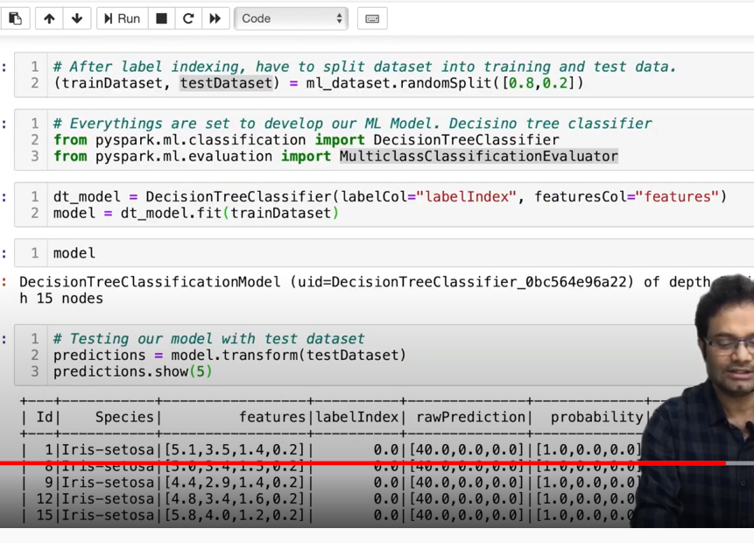

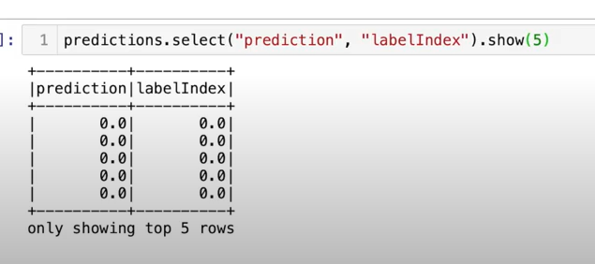

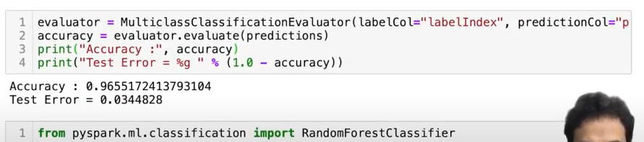

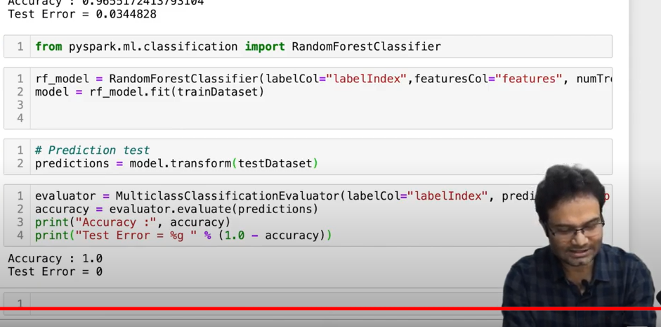

Spark MLlib Machine Learning Classification Model from scratch | Code walk through

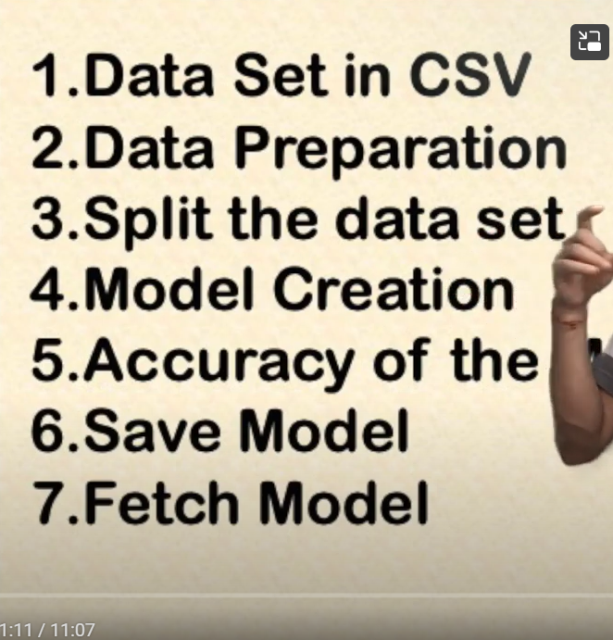

Pyspark

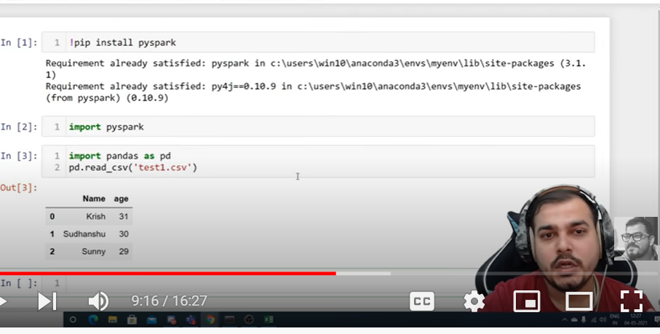

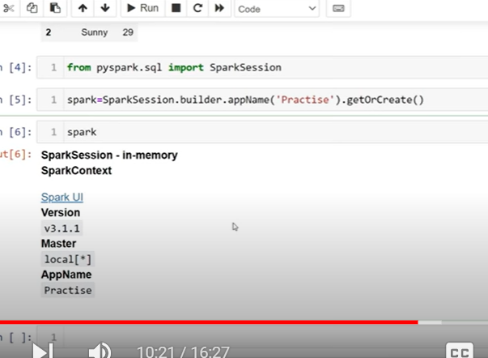

When we are working local one cluster

On cloud multiple clusters with master

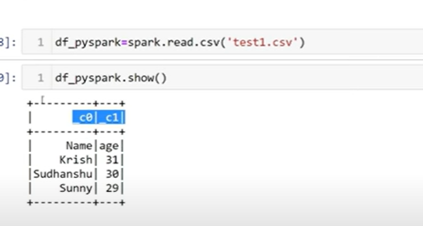

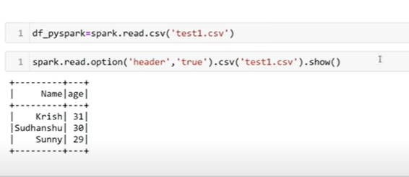

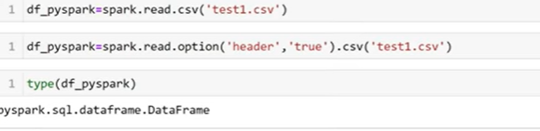

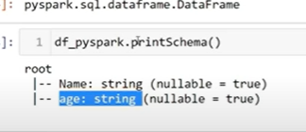

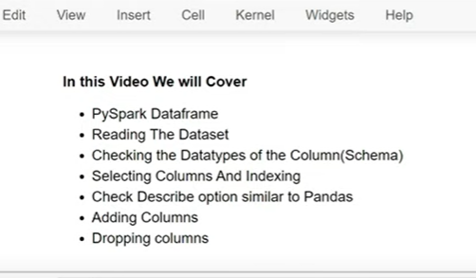

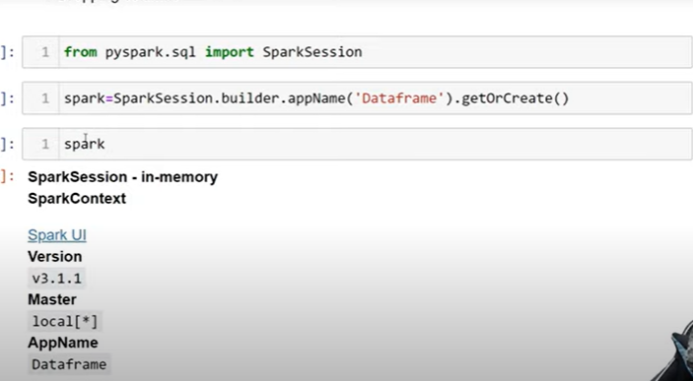

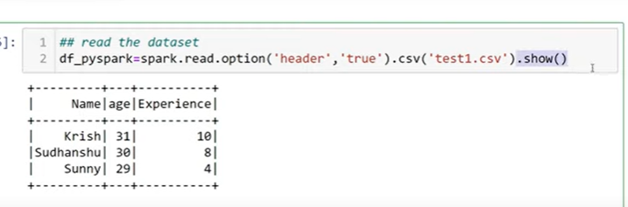

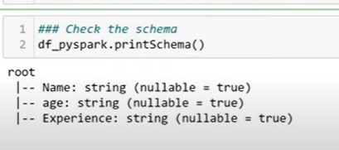

It consider all as string by default

To consider as int

inferschema

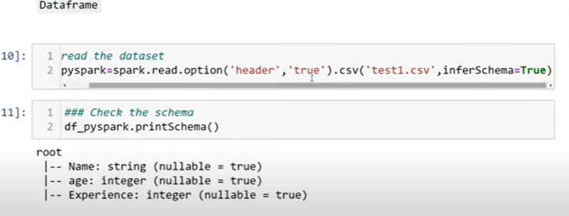

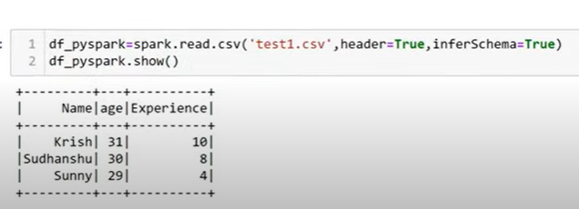

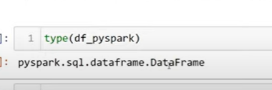

Data frame is a kind of data structures

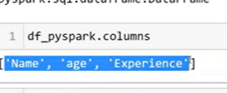

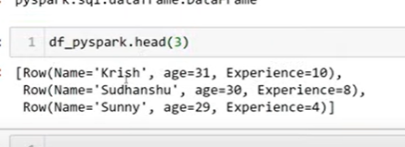

List format

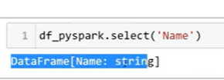

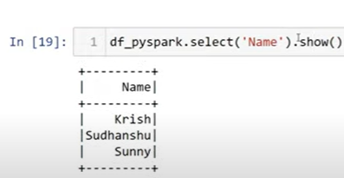

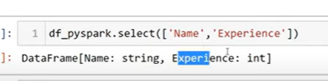

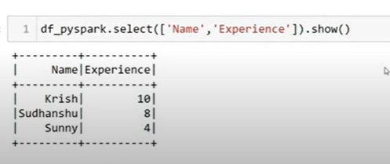

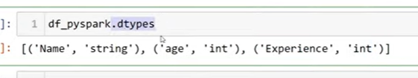

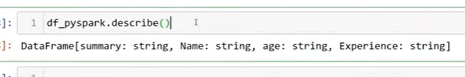

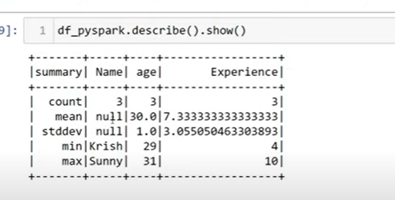

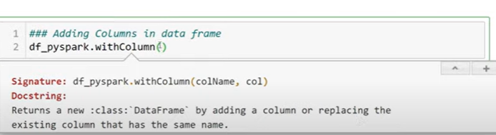

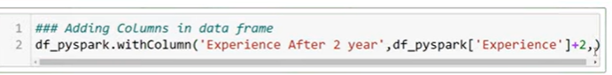

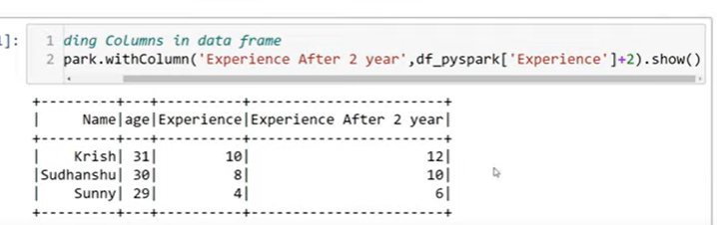

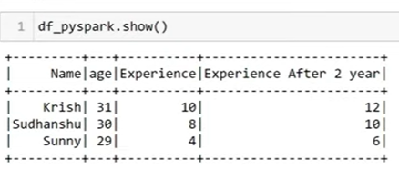

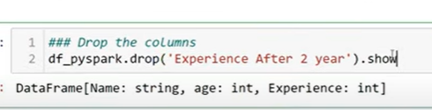

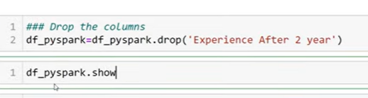

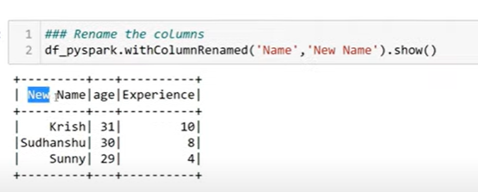

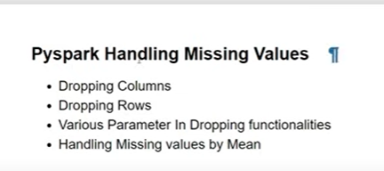

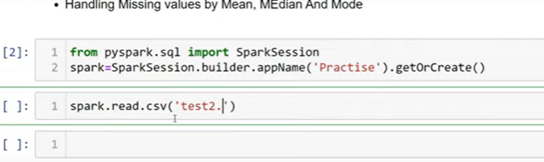

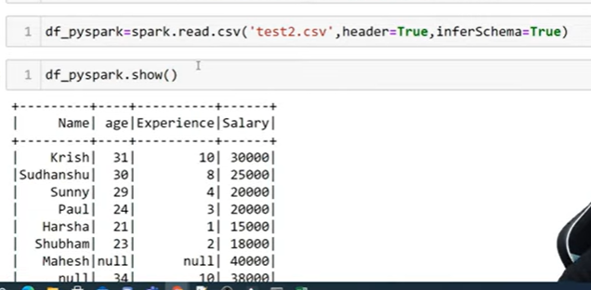

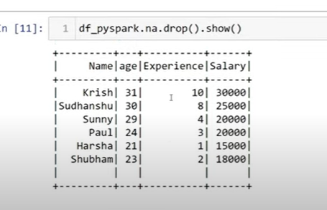

Rows with null values get deleted

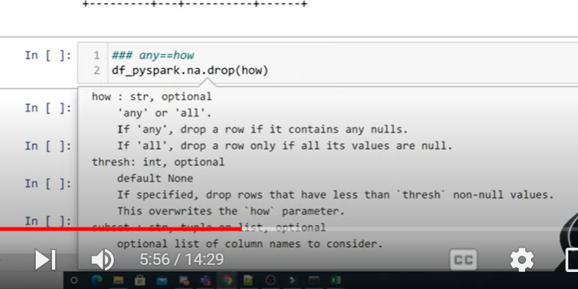

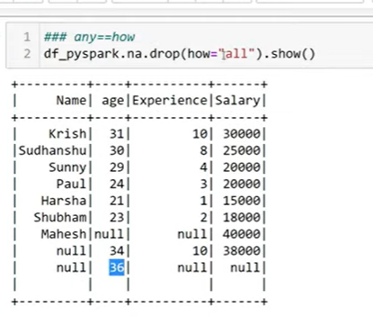

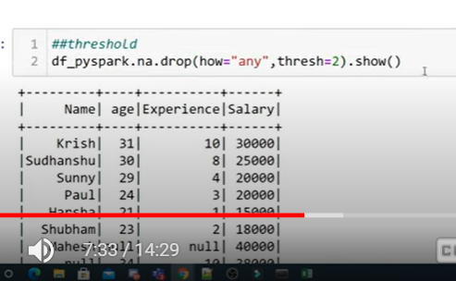

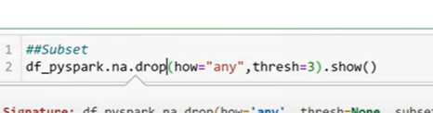

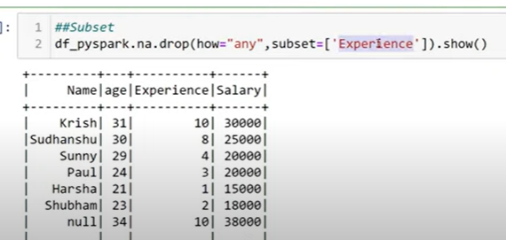

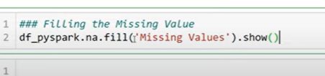

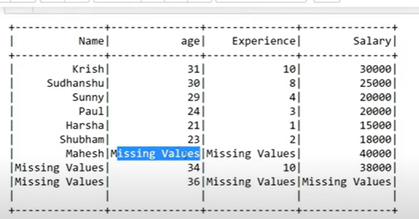

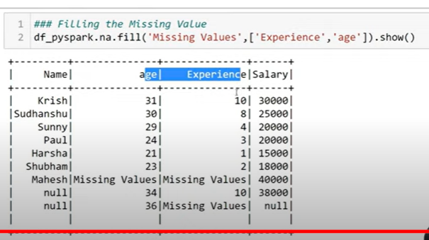

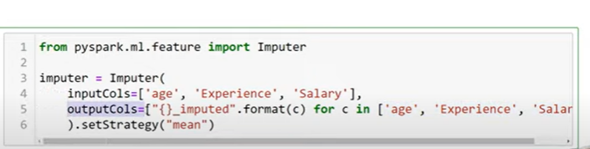

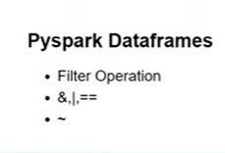

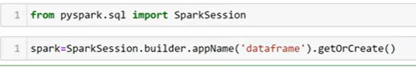

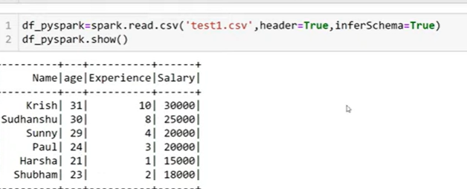

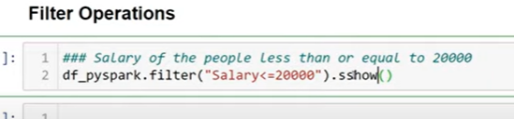

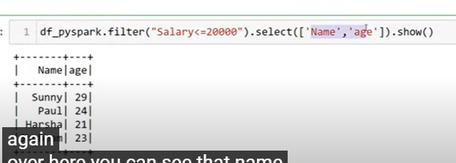

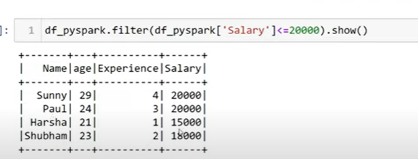

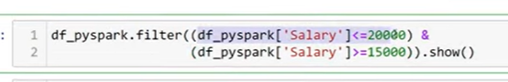

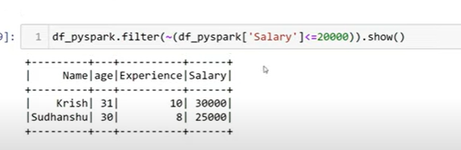

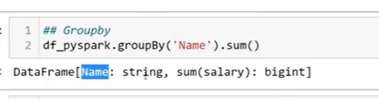

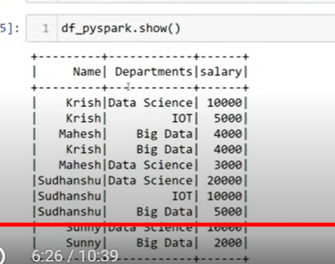

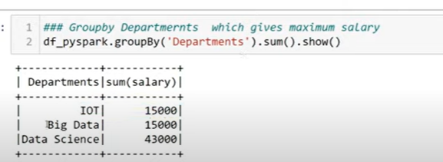

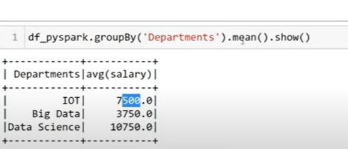

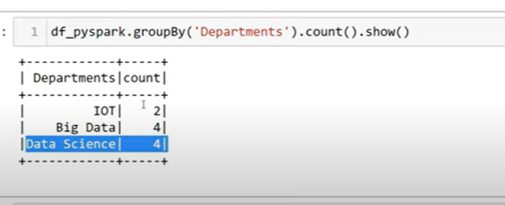

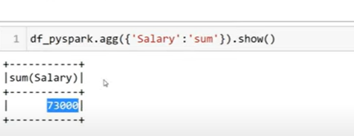

**Pyspark With Python-Introduction To Pyspark Mlib**

Spark ml has 2 techniques

RDD

Dataframe APIs

Dataframe api recent

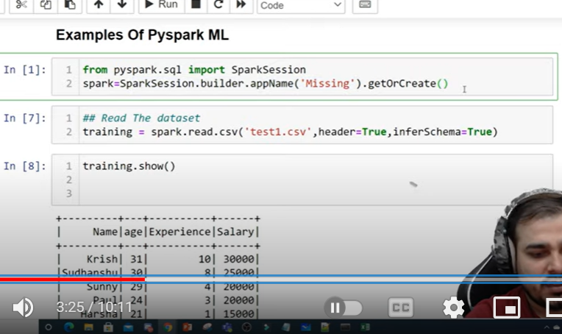

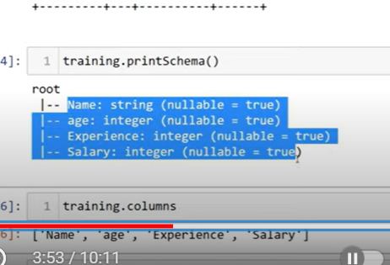

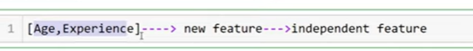

I have to group independent features as new future

Vectorassembler

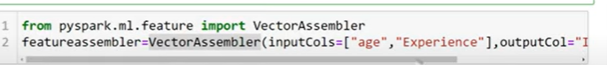

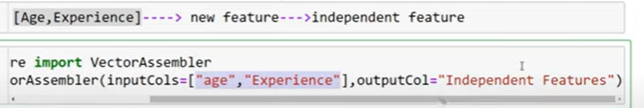

New column called idepedent feature

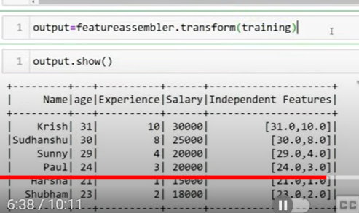

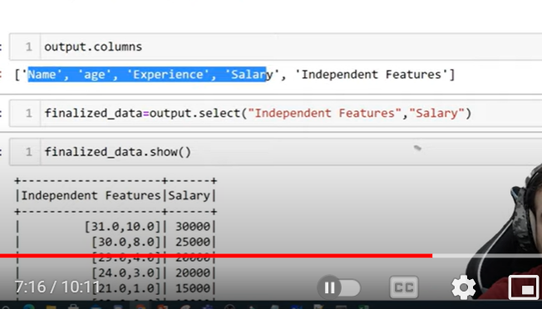

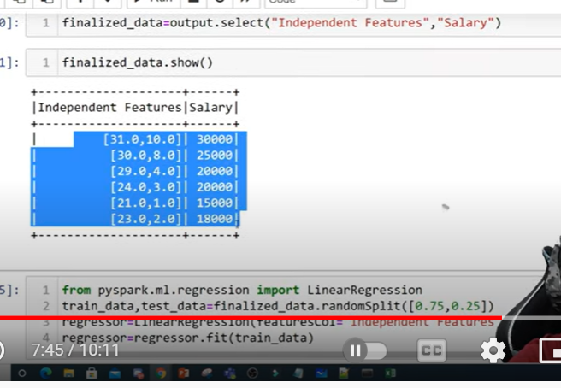

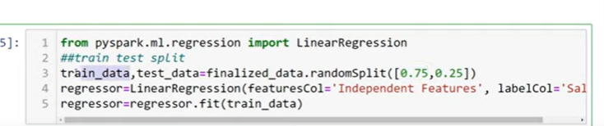

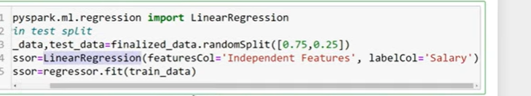

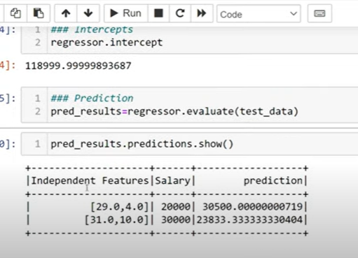

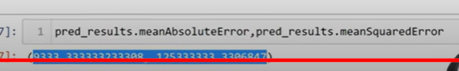

**Pyspark With Python|Introduction To Databricks**

Databricks platform

When I want to working with dataframe in multiple instances

Also used for mlflow

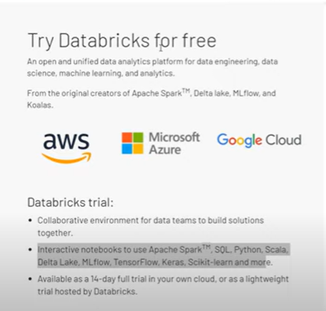

To work with huge data

Used to perform data engineering – big data

Community version has all below feature

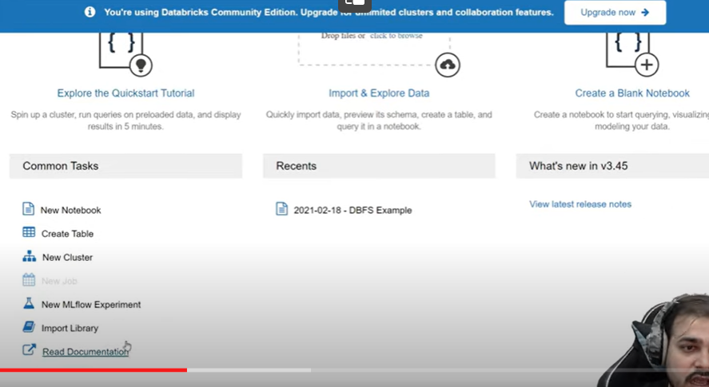

Create cluster



Create cluster

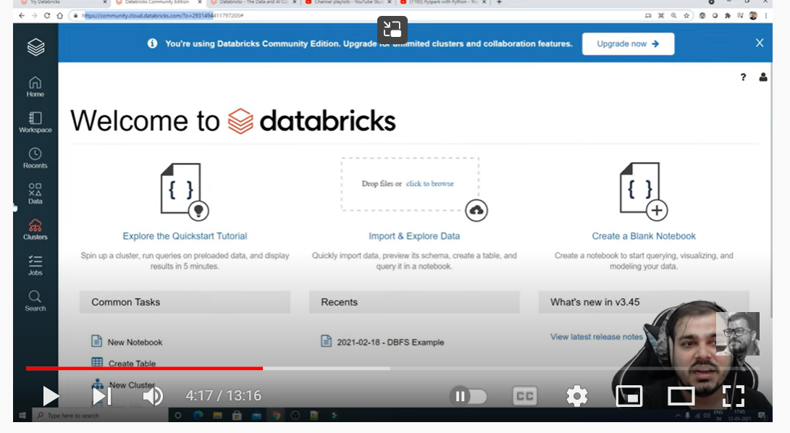

Clicking on red clusters

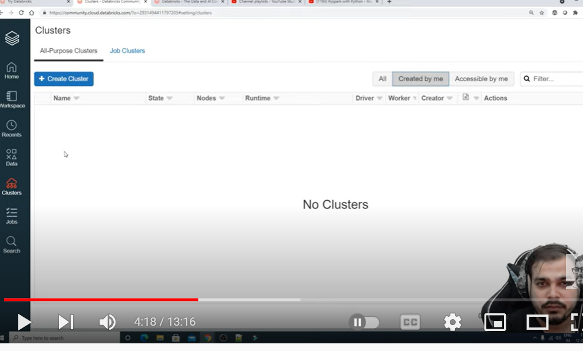

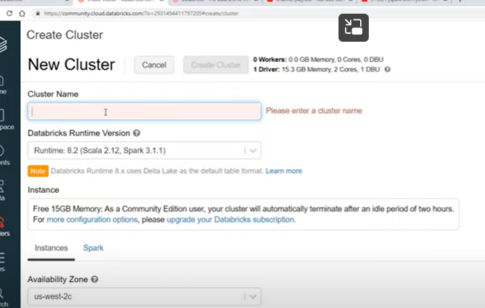

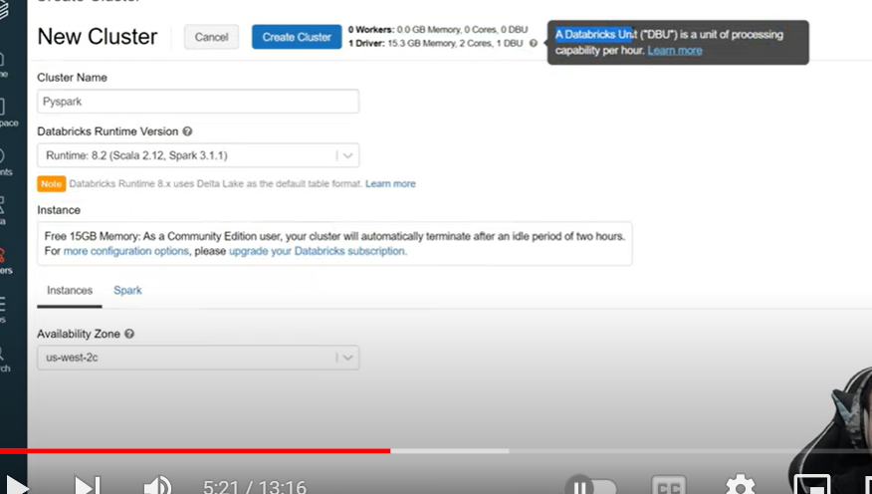

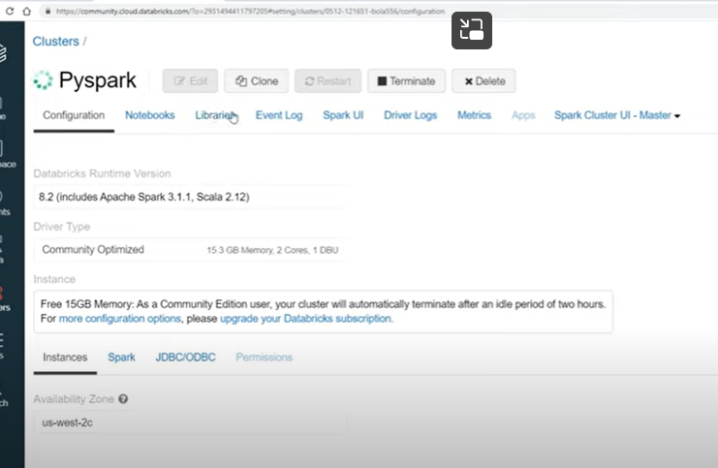

**DataFrame creation**

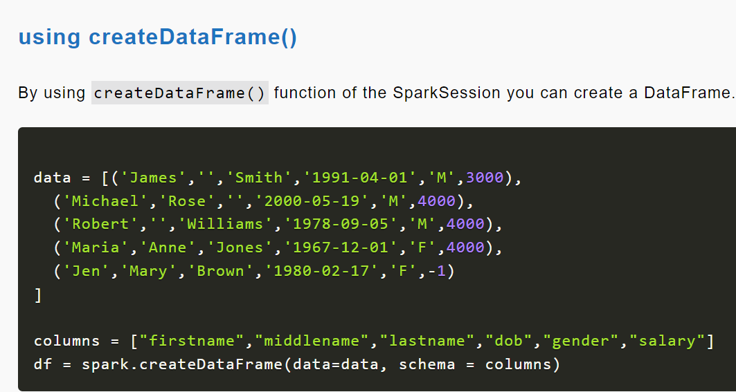

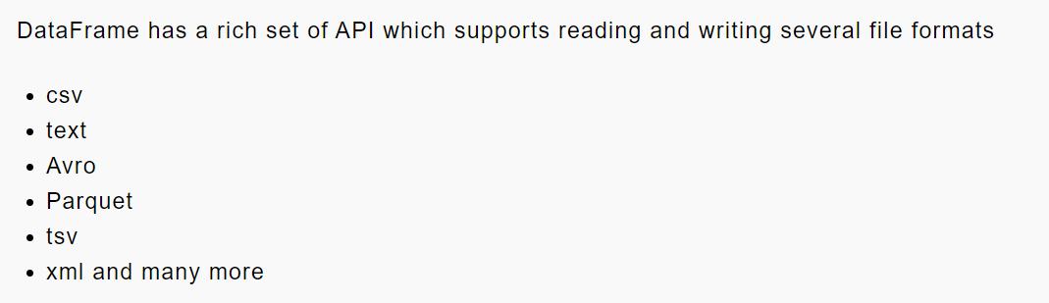

**Spark DataFrame – Fetch More Than 20 Rows & Column Full Value**

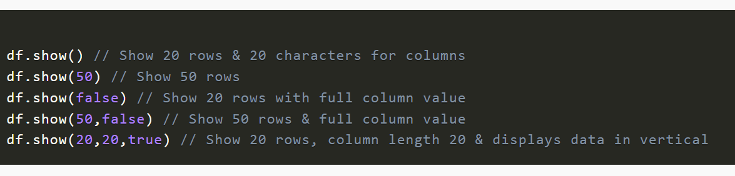

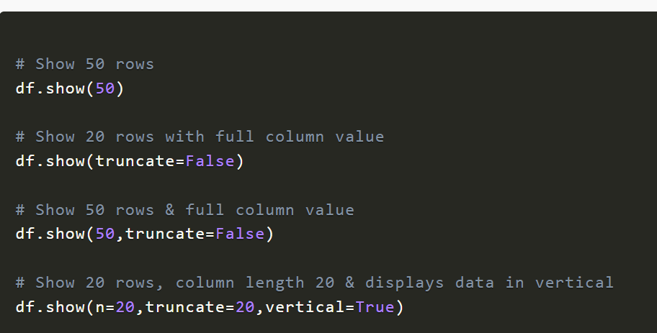

**Spark Check if Column Exists in DataFrame**

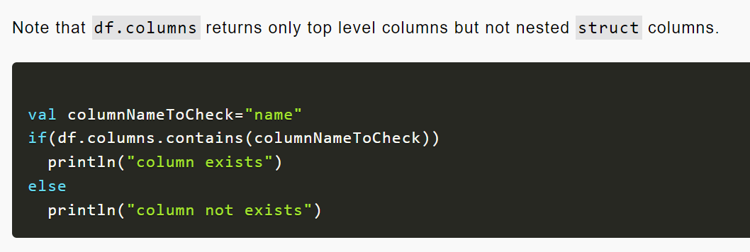

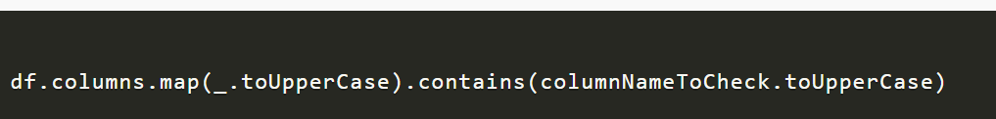

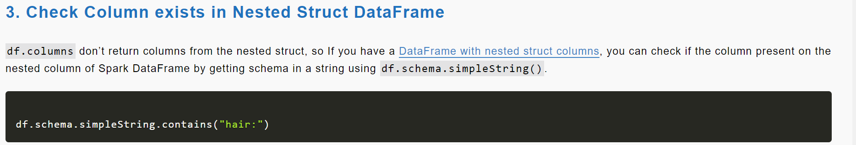

**PySpark withColumnRenamed to Rename Column on DataFrame**

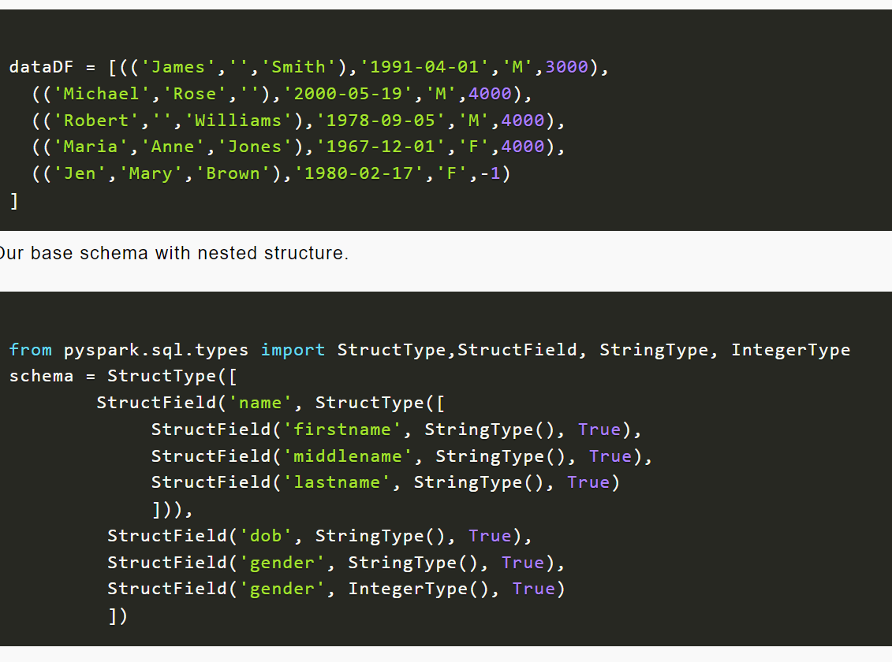

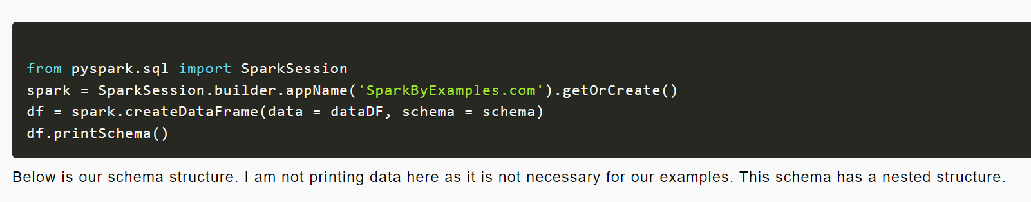

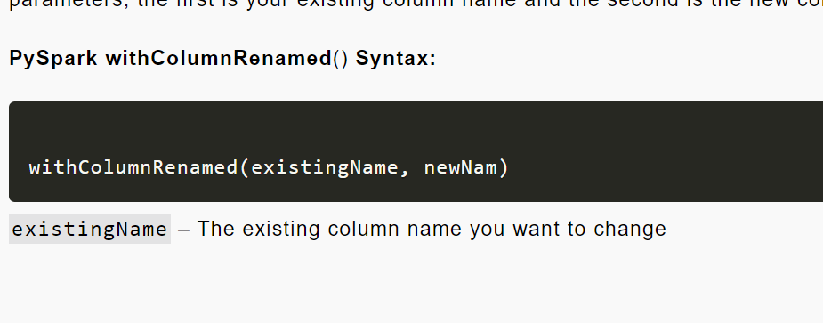

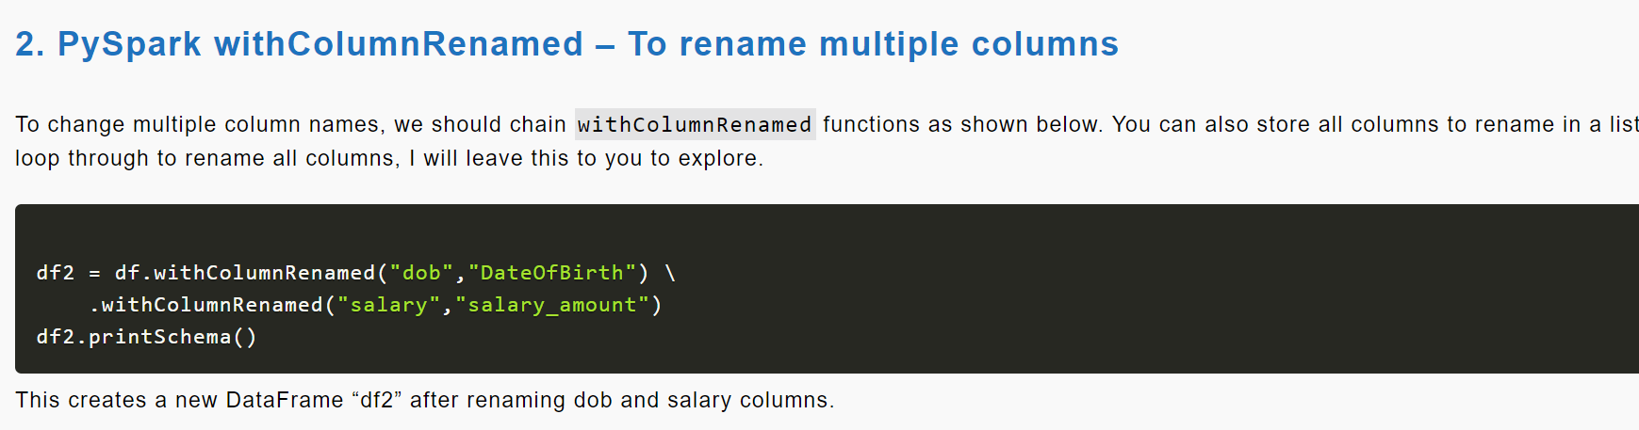

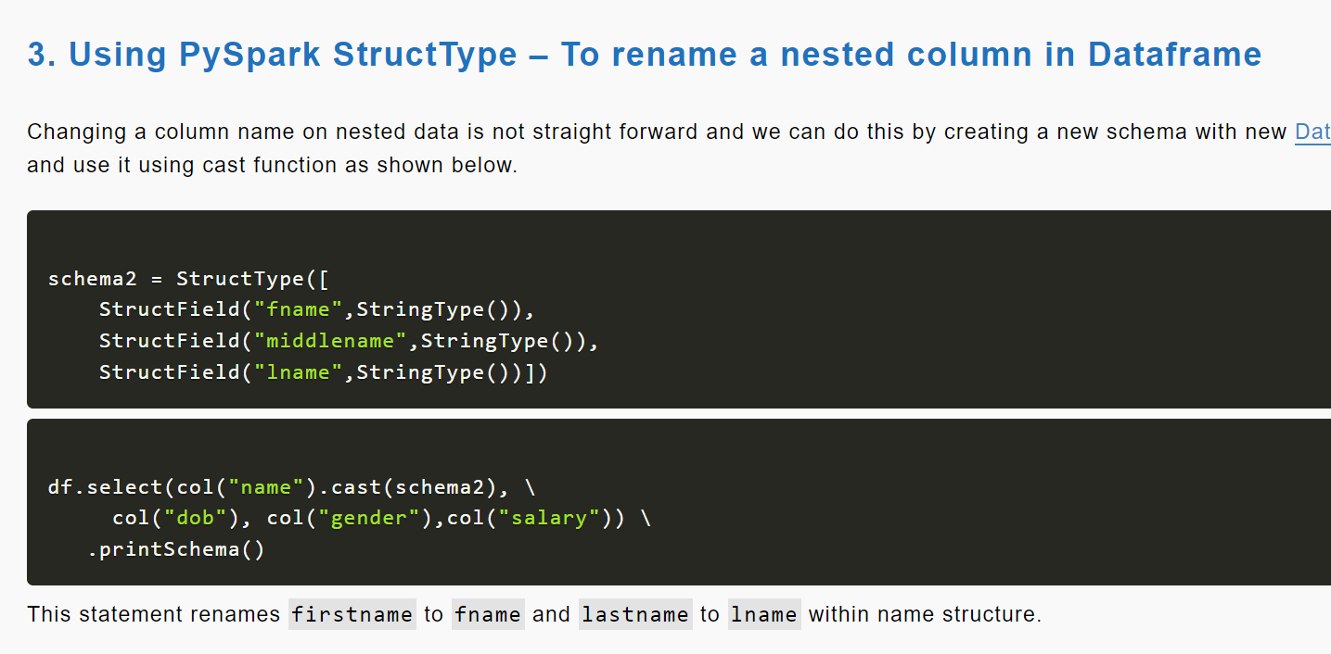

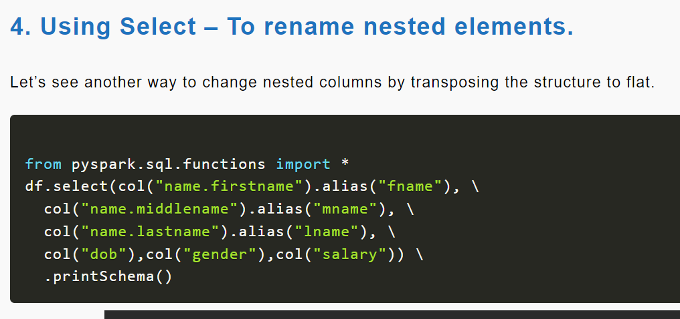

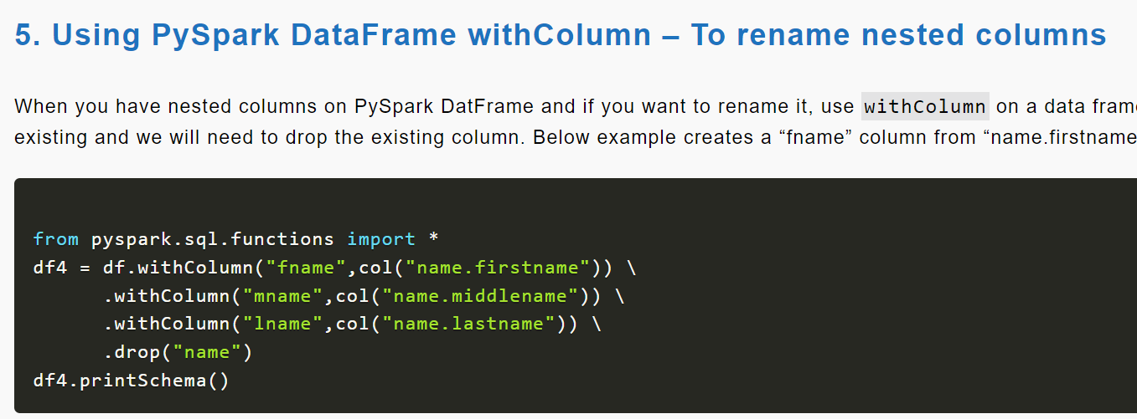

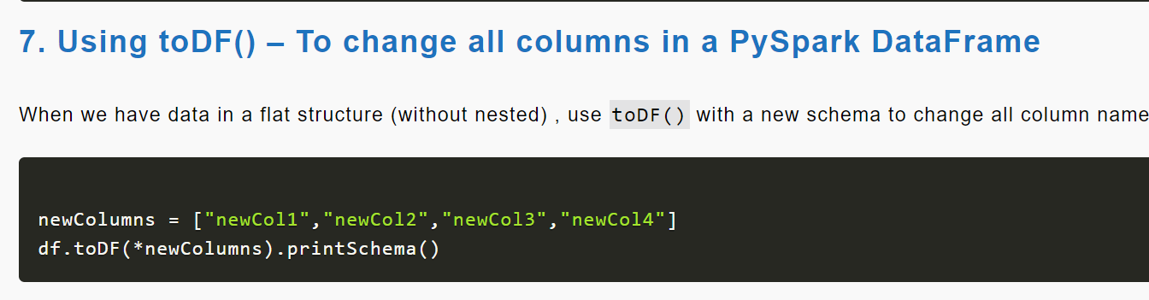

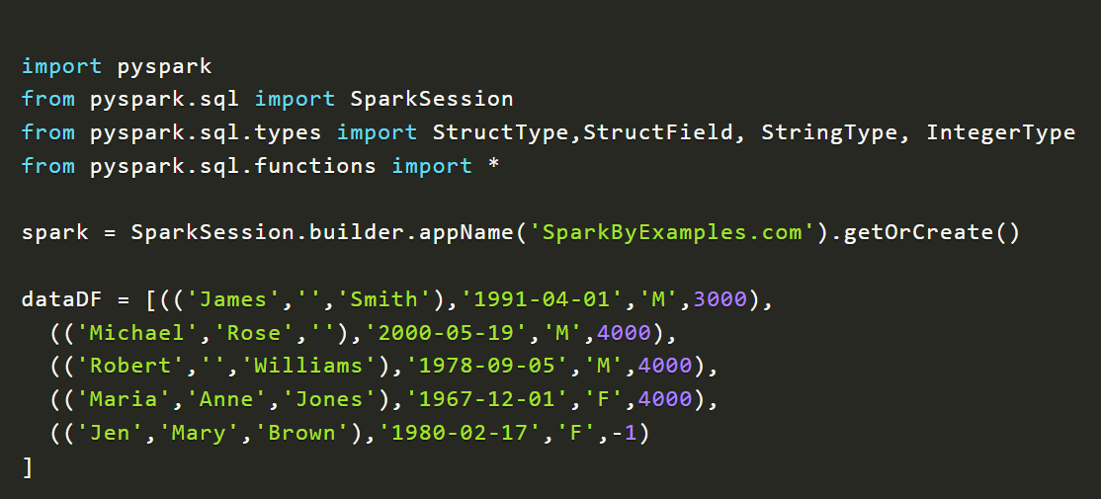

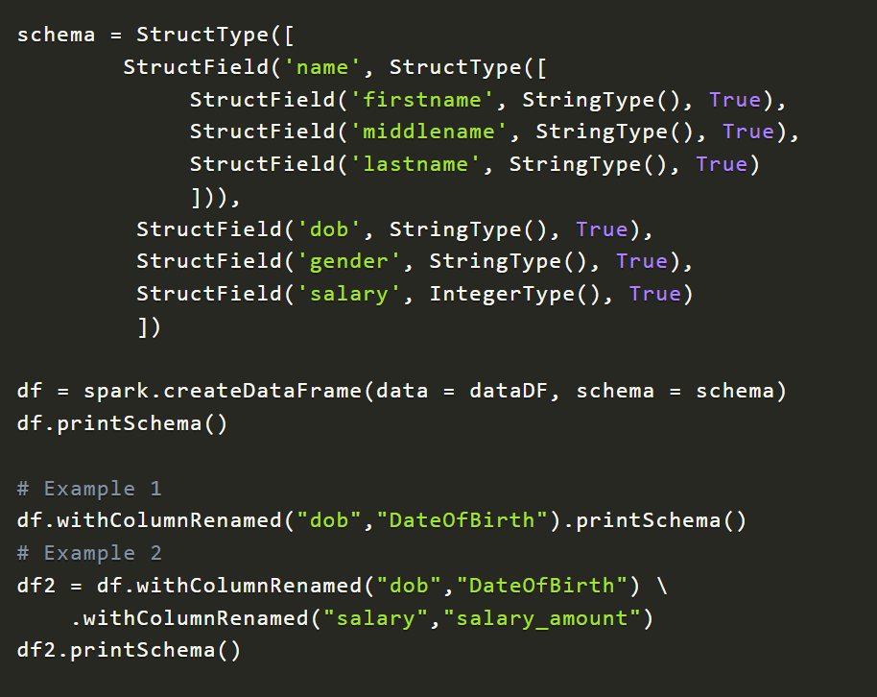

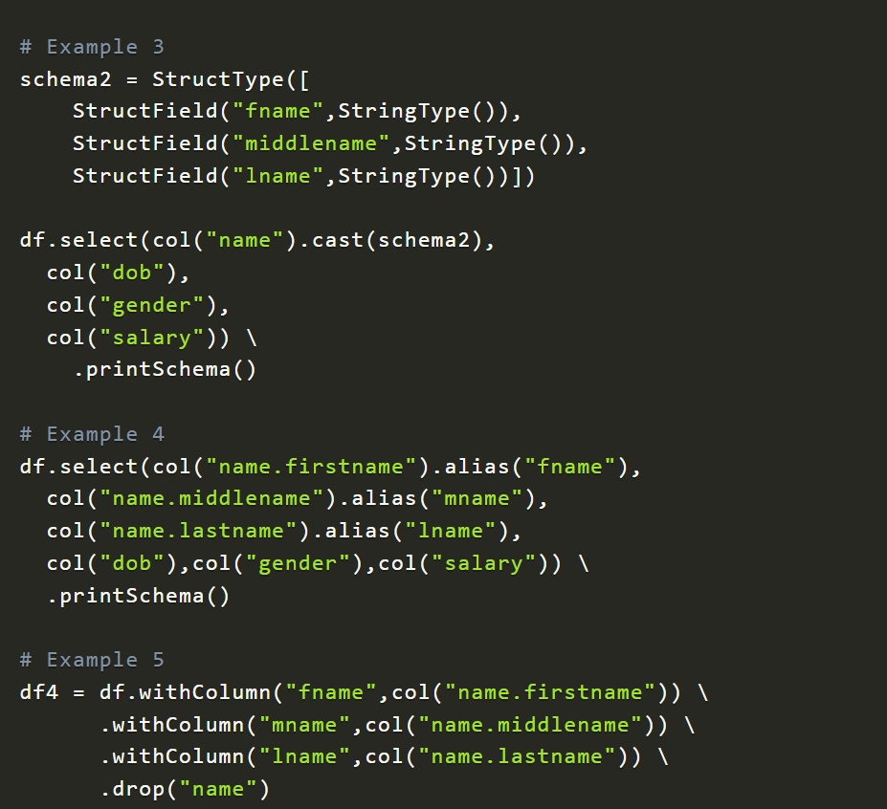

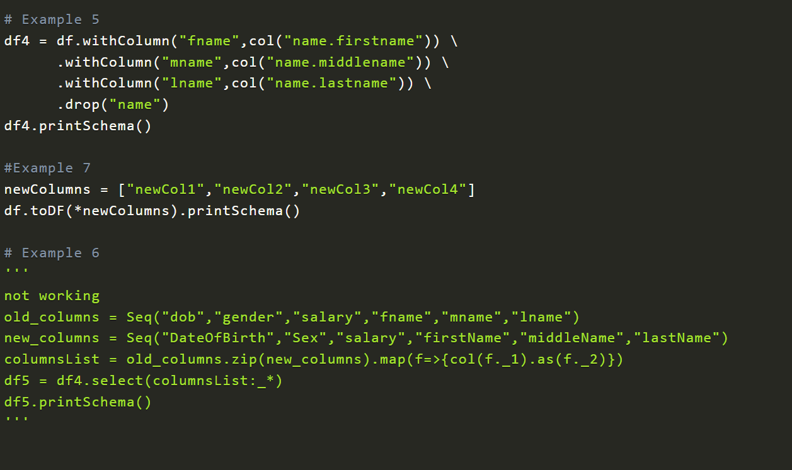

**PySpark withColumn() Usage with Examples**

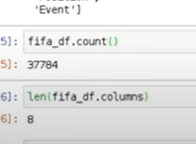

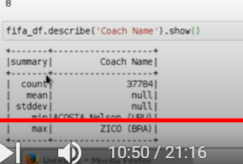

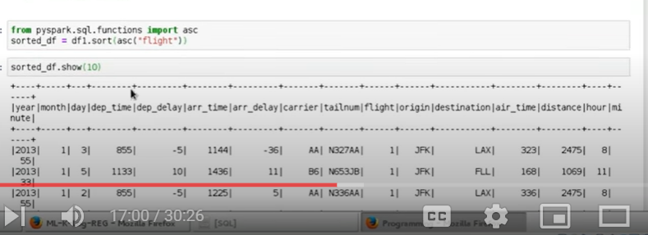

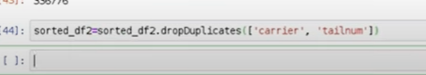

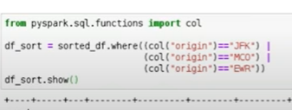

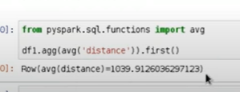

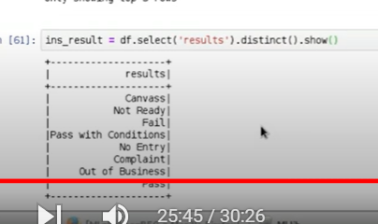

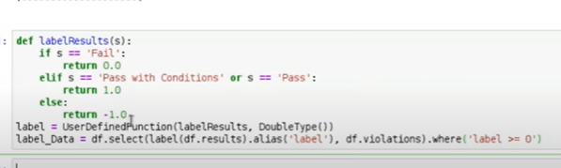

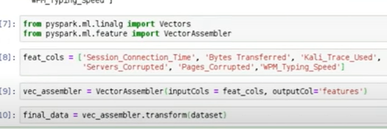

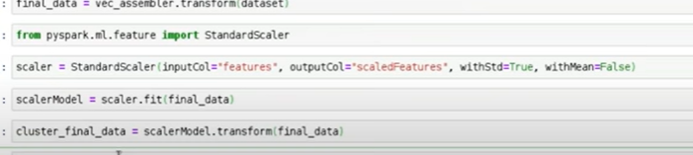

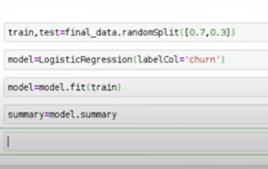

[Collaborative Filtering - Spark 3.3.0 Documentation (apache.org)](https://spark.apache.org/docs/latest/ml-collaborative-filtering.html)

[MLlib: Main Guide - Spark 3.3.0 Documentation (apache.org)](https://spark.apache.org/docs/latest/ml-guide.html)

<https://runawayhorse001.github.io/LearningApacheSpark/preface.html>

verbose: to get description